**MEDI-CAPS UNIVERSITY, INDORE- 453331**

**Department of Computer Science & Engineering**

**Faculty of Engineering**



**SOFTWARE WORKSHOP - II**

**Course Code: - CS3EA07**

**Lab Manual**

**Submitted by Submitted to**

**Dhananjay Porwal Ms. Shruti Jain**

**EN19CS301110**

**CS-B**

**Index**

|  |  |  |  |
| --- | --- | --- | --- |
| **S.no.** | **Name of Practical** | **Date of Practical** | **Remark** |
| 1. | Introduction to and installation of WEKA (Theoretical) | 18-08-21 |  |
| 2. | Familiarizing with ARFF file format | 25-08-21 |  |
| 3. | Linear Regression model and its implementation with a suitable data set. | 03-09-21 |  |
| 4. | Logistic Regression Model and its implementation on identifying the data set. | 15-09-21 |  |
| 5. | Naive Bayes Classifier and its implementation with a suitable data set | 29-09-21 |  |
| 6. | Decision tree algorithm and its implementation with a suitable data set. | 06-10-21 |  |
| 7. | Support Vector Machine algorithm and and its implementation with a suitable data set. | 13-10-21 |  |
| 8. | Identify a dataset for applying filters such as removing missing values and normalising data values. | 20-10-21 |  |
| 9. | K-Means Clustering Algorithm and its implementation and proper analysis of result by modifying values of K. | 27-10-21 |  |
| 10. | To apply Component Analysis and proper analysis of results with the help of Standard Deviation. | 10-11-21 |  |

**EXPERIMENT 1**

**1. Install Weka on your system and get familiarized with:**

**a. Step by Step explanation of installation.**

**b. Weka Introduction.**

**c. Advantages and Disadvantages of using Weka.**

**d. Minimum hardware requirement**

**WEKA Download And Installation**

**1.** ToDownload the software .

Check the configuration of the computer system and download the stable version of WEKA (currently 3.8) from this page.

[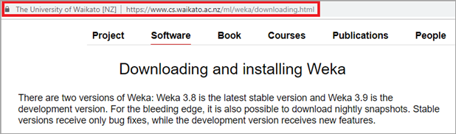](https://www.softwaretestinghelp.com/wp-content/qa/uploads/2020/07/Download-and-Installation-of-WEKA-1.png)

**2.**After successful download, open the file location and double click on the downloaded file. The Step Up wizard will appear. Click on Next.

[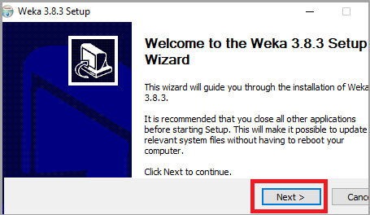](https://www.softwaretestinghelp.com/wp-content/qa/uploads/2020/07/Step-Up-wizard-1.png)

**3.**The License Agreement terms will open. Read it thoroughly and click on “I Agree”.

[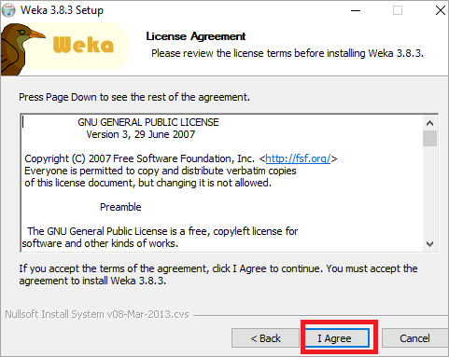](https://www.softwaretestinghelp.com/wp-content/qa/uploads/2020/07/The-License-Agreement-Terms.png)

**4.**According to your requirements, select the components to be installed. Full component installation is recommended. Click on Next.

[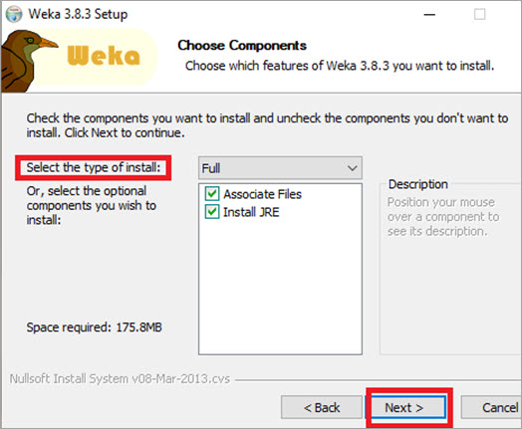](https://www.softwaretestinghelp.com/wp-content/qa/uploads/2020/07/select-the-components-to-be-installed.jpg)

**5.**Select the destination folder and Click on Next.

[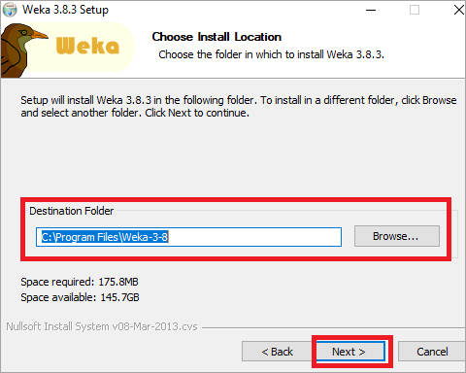](https://www.softwaretestinghelp.com/wp-content/qa/uploads/2020/07/destination-folder.png)

**6.**Then, Installation will start.

[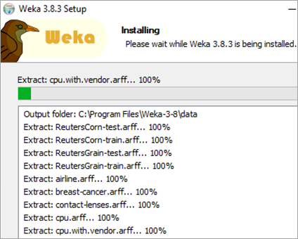](https://www.softwaretestinghelp.com/wp-content/qa/uploads/2020/07/Installation-Window.png)

**7.**If Java is not installed in the system, it will install Java first.

[](https://www.softwaretestinghelp.com/wp-content/qa/uploads/2020/07/Java-1.png)

**8.**After the installation is complete, the following window will appear. Click on Next.

[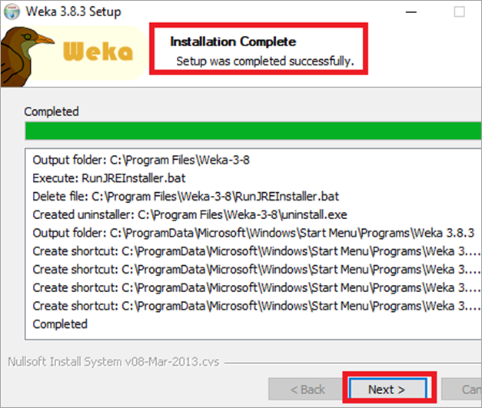](https://www.softwaretestinghelp.com/wp-content/qa/uploads/2020/07/Installation-Complete-Window.png)

**9.**Select the Start Weka checkbox. Click on Finish.

[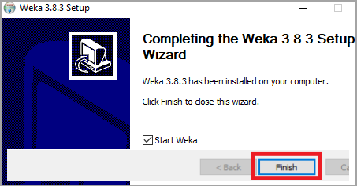](https://www.softwaretestinghelp.com/wp-content/qa/uploads/2020/07/Explorer-Opens-1.png)

## What Is WEKA

Weka is an open-source tool designed and developed by the scientists/researchers at the University of Waikato, New Zealand. WEKA stands for Waikato Environment for Knowledge Analysis. It is developed by the international scientific community and distributed under the free GNU GPL license.

WEKA is fully developed in Java. It provides integration with the SQL database using Java Database connectivity. It provides many machine learning algorithms to implement data mining tasks. These algorithms can either be used directly using the WEKA tool or can be used with other applications using Java programming language.

It provides a lot of tools for data preprocessing, classification, clustering, regression analysis, association rule creation, feature extraction, and data visualization. It is a powerful tool that supports the development of new algorithms in machine learning.

**Advantages**:

* Free availability under the GNU General Public License.
* Portability, since it is fully implemented in the Java programming language and thus runs on almost any modern computing platform.
* A comprehensive collection of data preprocessing and modeling techniques.
* Ease of use due to its graphical user interfaces.

**Disadvantages**:

* they do not implement the newest techniques.
* the documentation for the GUI is quite limited.
* A third possible problem is scaling.
* the GUI does not implement all the possible options.
* the data preparation and visualisation techniques offered might not be enough.

**System Requirement for Weka**

Per Host Memory.

Fixed. 2.3 GB.

Core-based. 2.3 GB for each Frontend core. 3.3 GB for each Compute core. 2.3 GB for each Drive/SSD core.

Capacity requirement. See below.

Reserved for Operating System. 8 GB.

Reserved for SMB/NFS services. 8 GB.

**EXPERIMENT 2**

**Get familiarized with the arff file format. Create an arff file on your system and save it in the WEKA installed drive of your system.**

**Theory-**

This operator can read ARFF (Attribute-Relation File Format) files known from the machine learning library Weka. An ARFF file is an ASCII text file that describes a list of instances sharing a set of attributes. ARFF files were developed by the Machine Learning Project at the Department of Computer Science of The University of Waikato for use with the Weka machine learning software. Please study the attached Example Process for understanding the basics and structure of the ARFF file format. Please note that when an ARFF file is written, the roles of the attributes are not stored. Similarly, when an ARFF file is read, the roles of all the attributes are set to regular.

**ARFF file content created in notepad-**

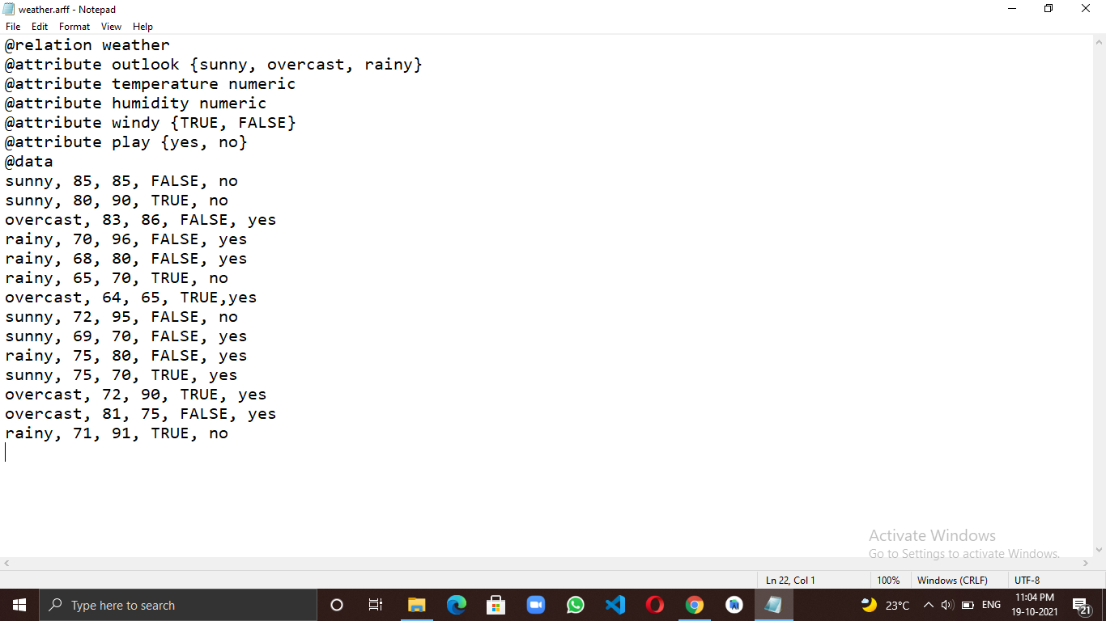

**ARFF File in weka-**

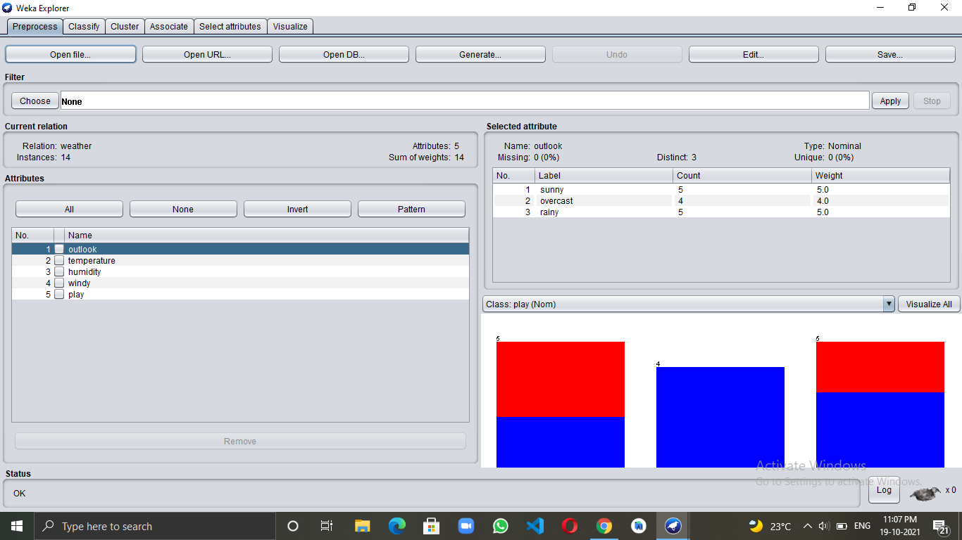

**EXPERIMENT 3**

**Execute the Linear Regression algorithm on WEKA with the help of a suitable data set. Analyze the result. When you select your data try to do the splitting of data set for training and testing as:**

1. **Training 80% and Testing 20%**
2. **Training 60% and Testing 40%**

**Theory:**

**Linear Regression algorithm:** Linear Regression is a machine learning algorithm based on supervised learning. It performs a regression task. Regression models a target prediction value based on independent variables. It is mostly used for finding out the relationship between variables and forecasting. Different regression models differ based on – the kind of relationship between dependent and independent variables, they are considering and the number of independent variables being used.

**What type of data is used in linear regression?**

One of the most basic types of regression in machine learning, linear regression comprises **a predictor variable and a dependent variable related to each other in** a linear fashion. Linear regression involves the use of a best-fit line, as described above.

**Step by step procedure for applying Linear Regression in WEKA-**

**Training 80% and Testing 20%-**

**Step 1-**

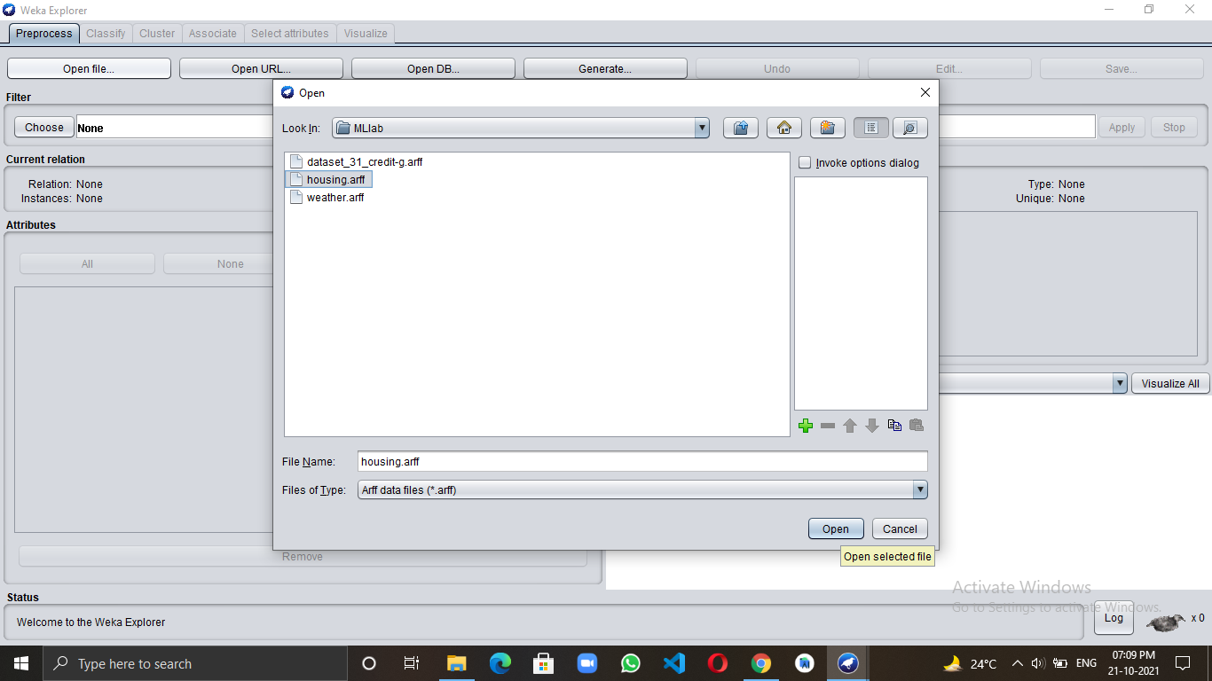

**Step 2-**

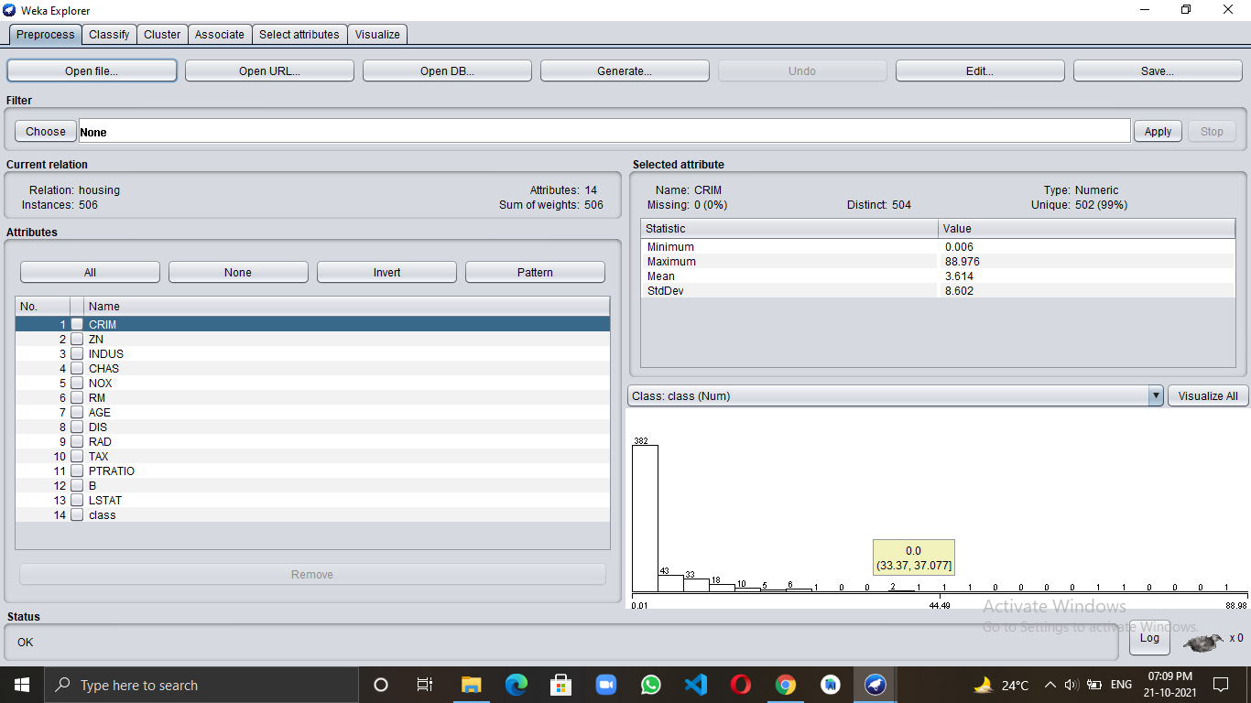

**Step 3-**

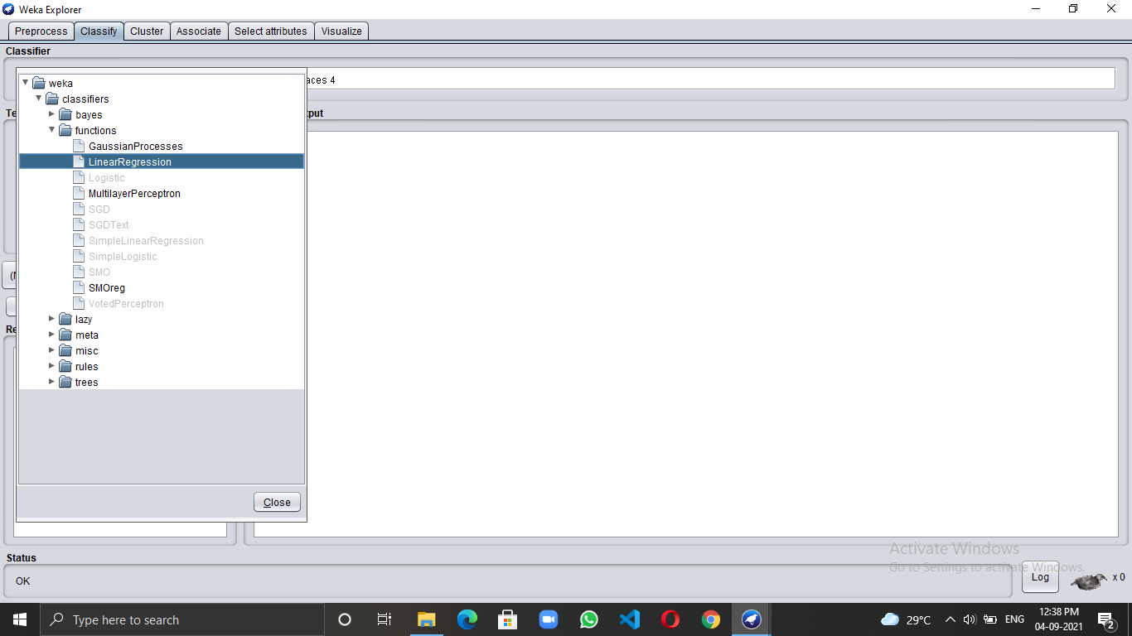

**Step 4-**

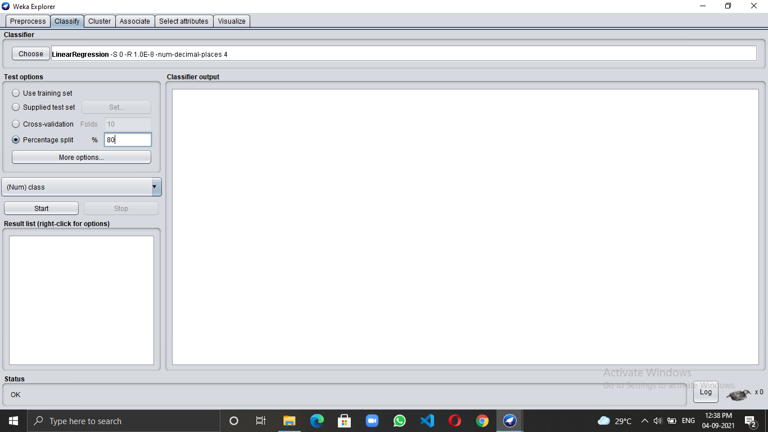

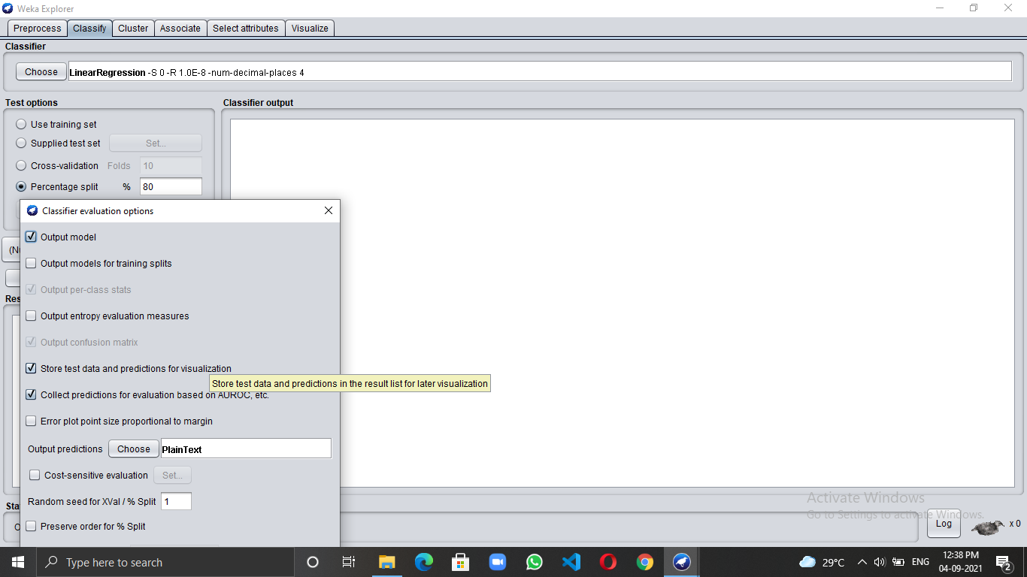**Step 5-**

**Step 6-**

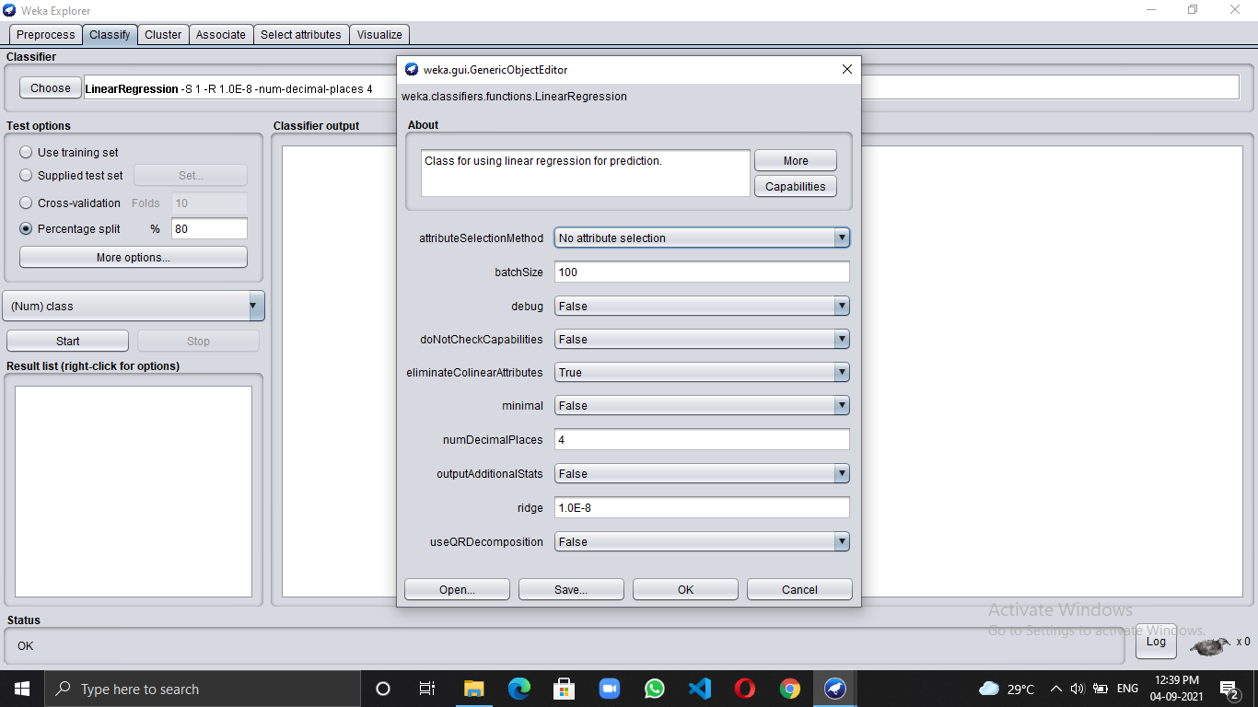

**Final Output-** After clicking on the Start button we get output

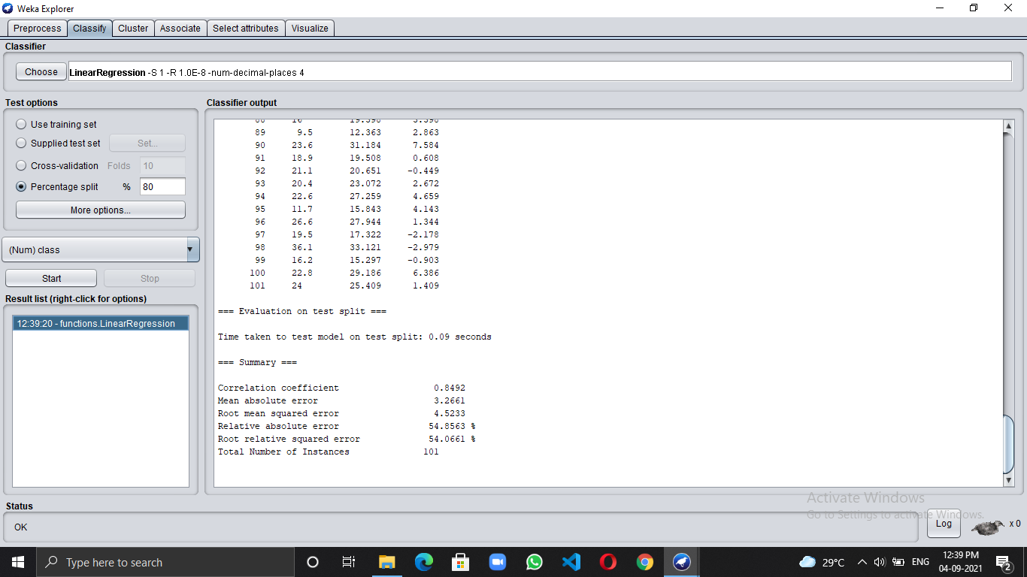

**Analyze the result-**

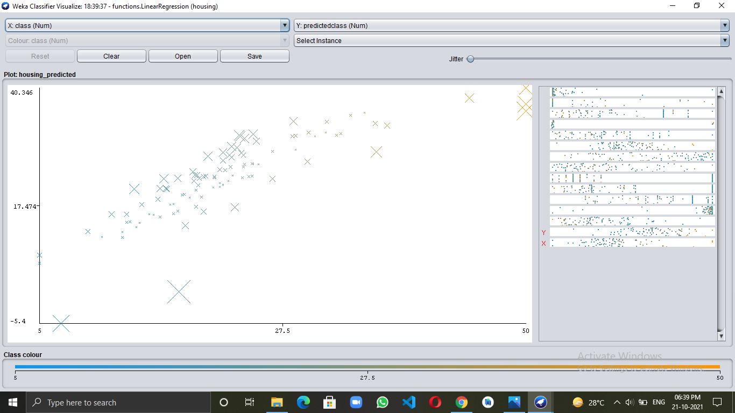

**Trainin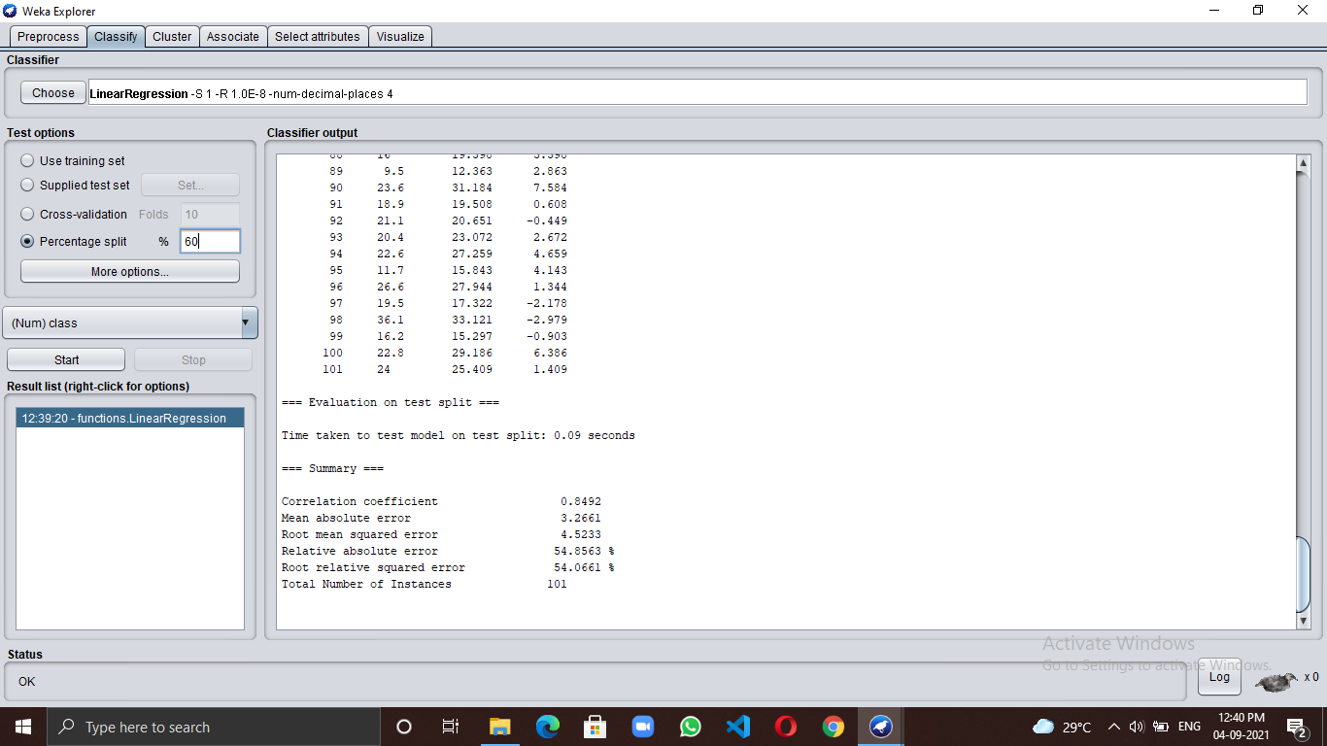g 60% and Testing 40%-**

**Final Output-** After clicking on the Start button we get output

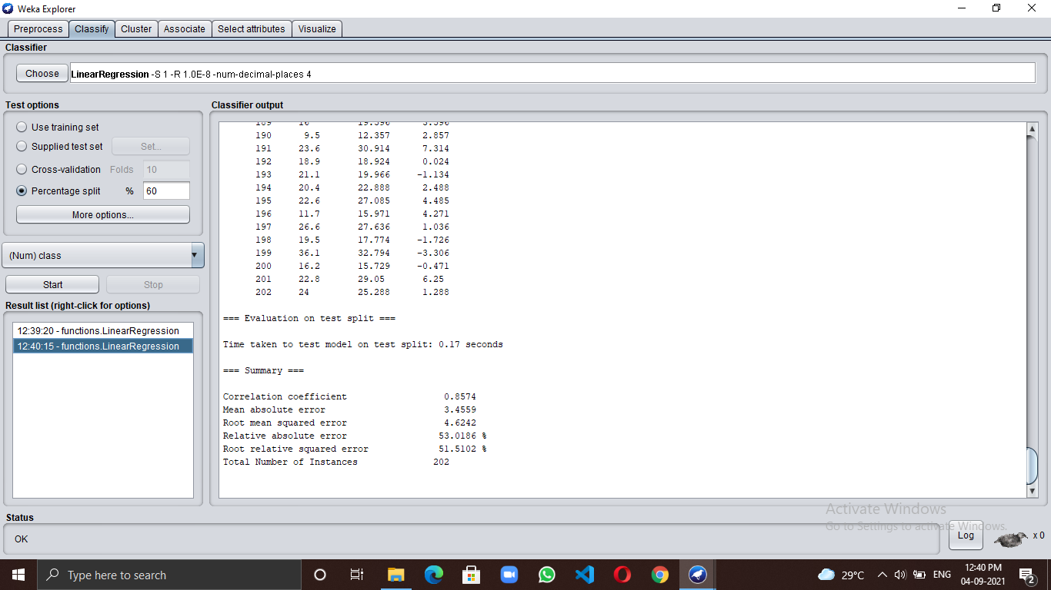

**Analyze the result-**

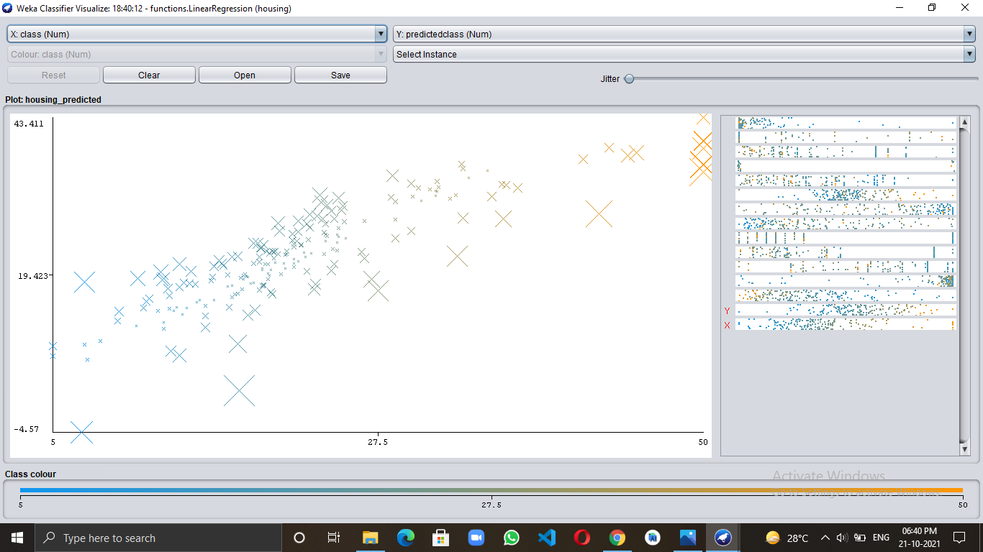

**EXPERIMENT 4**

**Execute the Logistic Regression with the help of a properly-identified data set. Analyze the result and identify how well the model performed on the test set. Brief the steps that you have followed to analyze the dataset.**

**Theory:**

**Logistic regression:** It is a supervised learning classification algorithm used to predict the probability of a target variable. The nature of the target or dependent variable is dichotomous, which means there would be only two possible classes.

In simple words, the dependent variable is binary in nature having data coded as either 1 (stands for success/yes) or 0 (stands for failure/no).

Mathematically, a logistic regression model predicts P(Y=1) as a function of X. It is one of the simplest ML algorithms that can be used for various classification problems such as spam detection, Diabetes prediction, cancer detection, etc.

**Which type of dataset is used for logistic regression?**

Logistic regression is used for **binary or multi-class classification**, and the target variable always has to be categorical.

Binary classification is when we have two possible outcomes like a person is infected with COVID-19 or is not infected with COVID-19. In multi-class classification, we have multiple outcomes like the person may have the flu or an allergy, or cold or COVID-19.

**Step by step procedure for applying Logistic Regression in WEKA using 80% Training set and 20% Testing-**

**Step 1-**

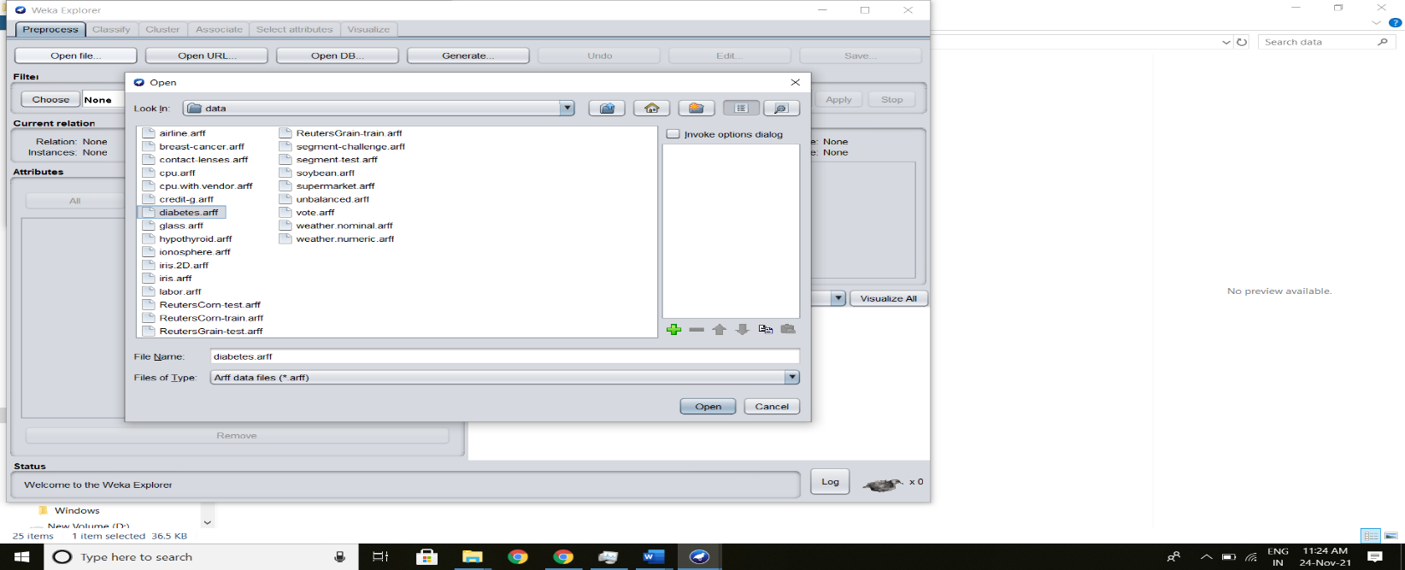

**Step 2-**

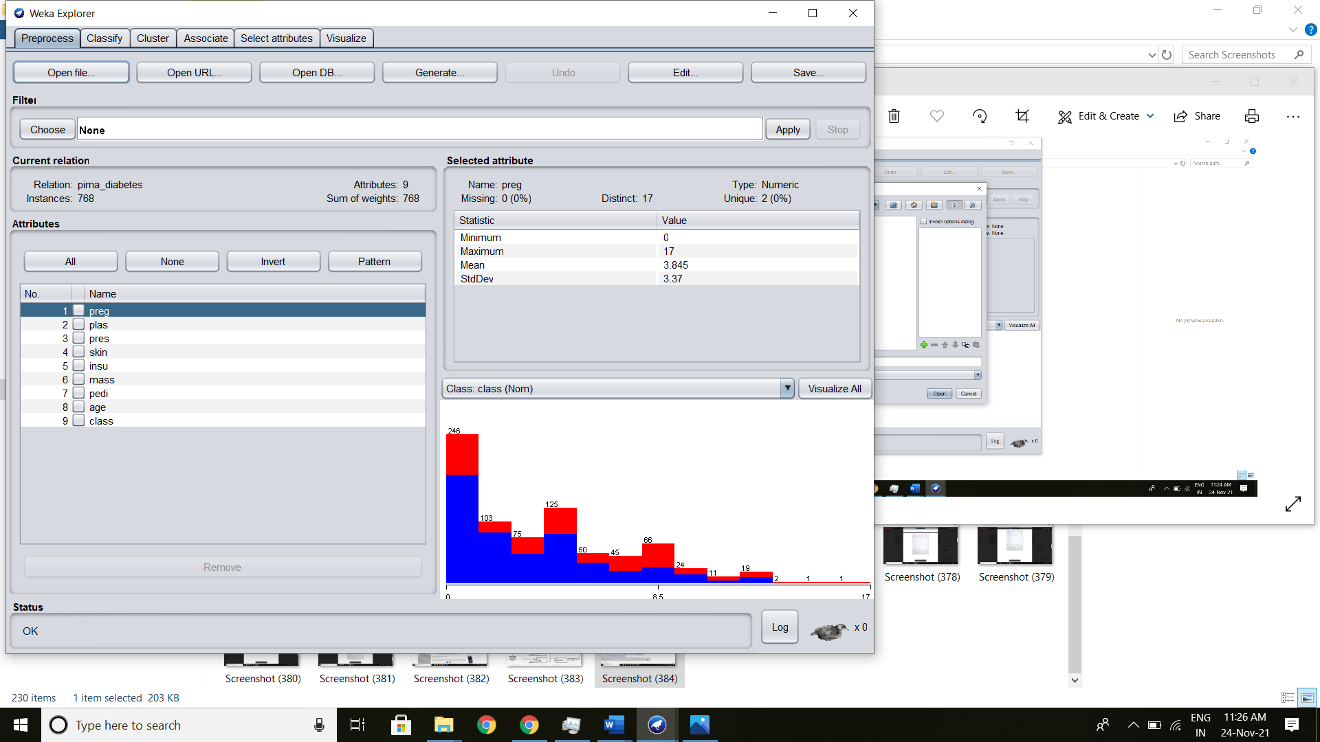

**Step 3-**

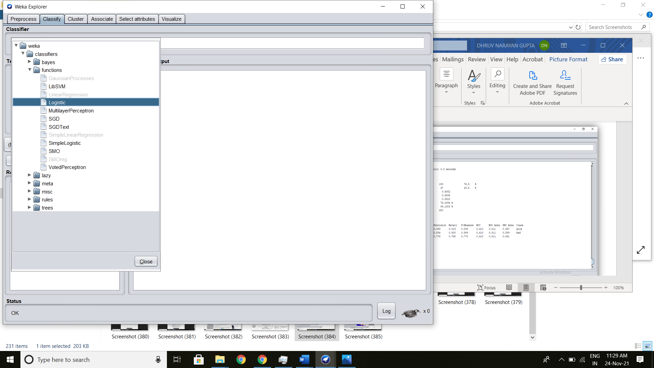

**Step 4-**

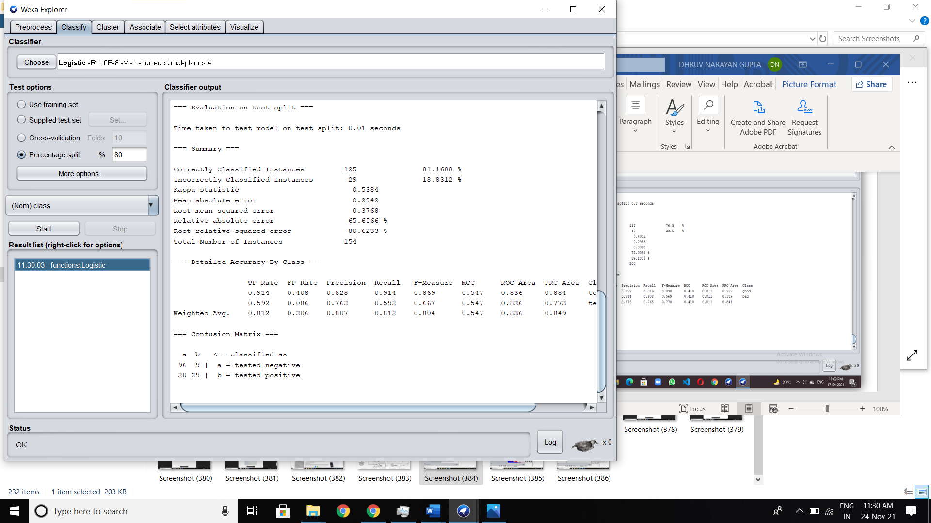

**Step 5-**

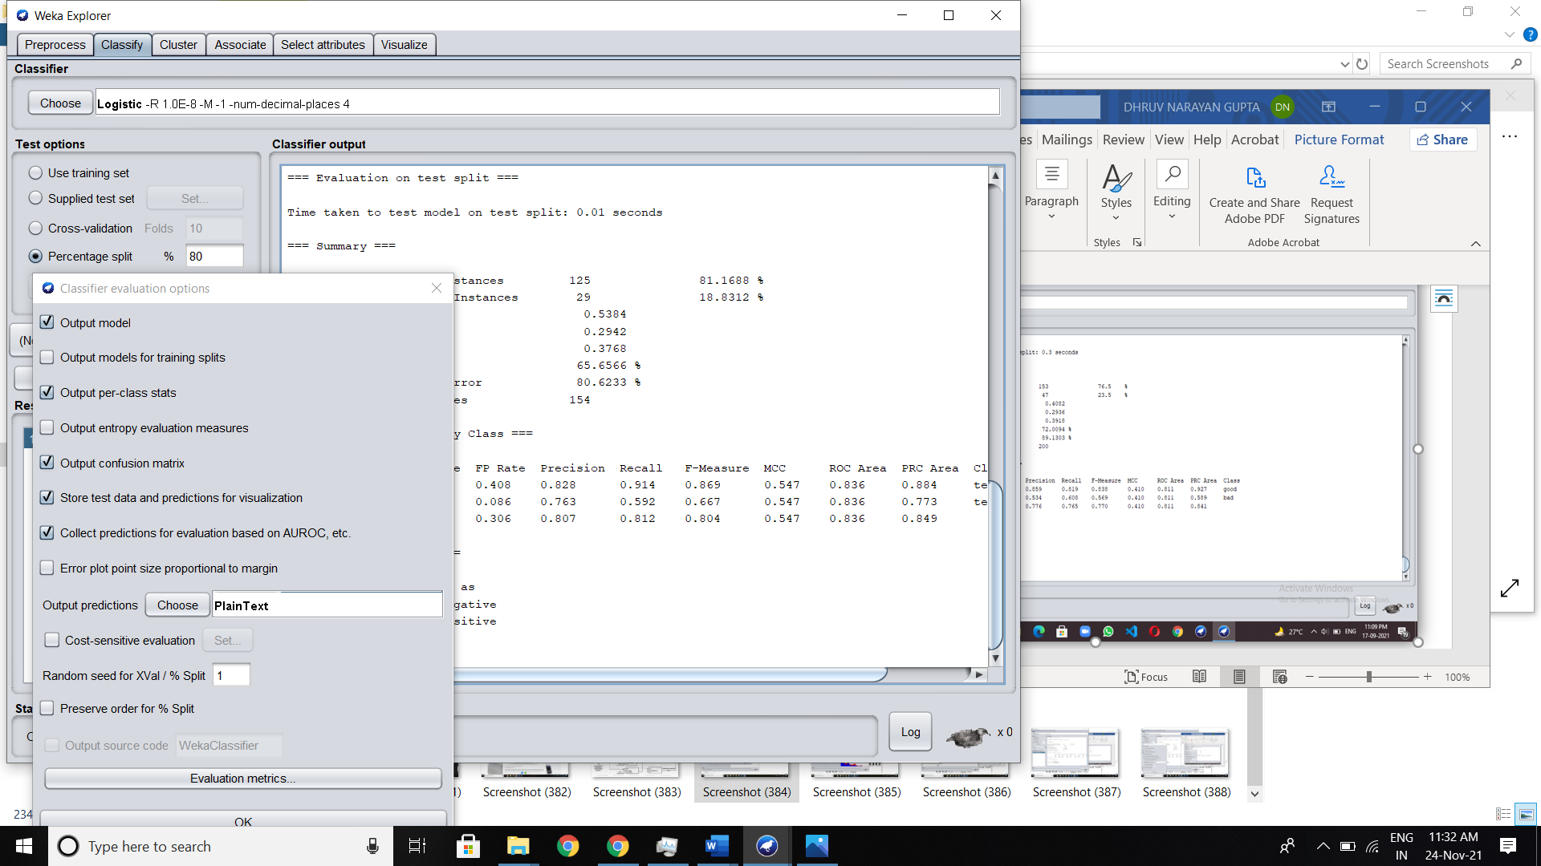

**Output-** After clicking on the Start button we get output

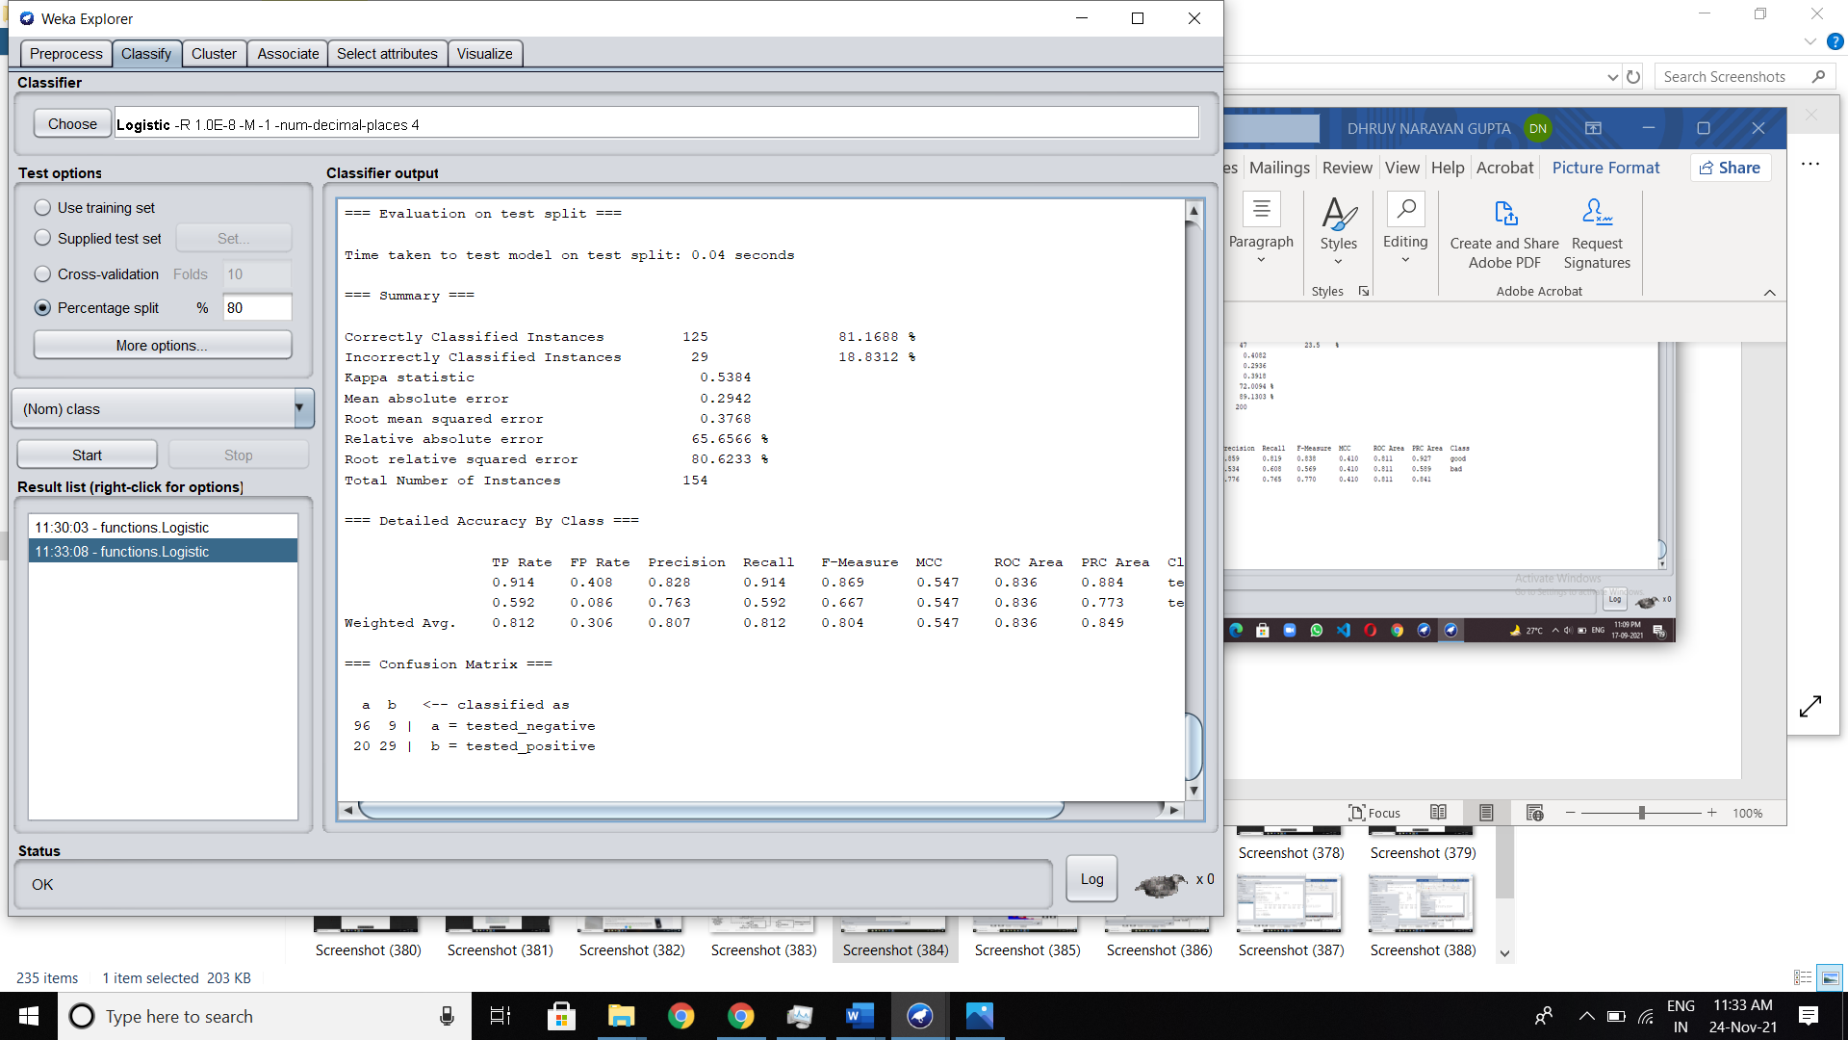

**Analyze the Result-**

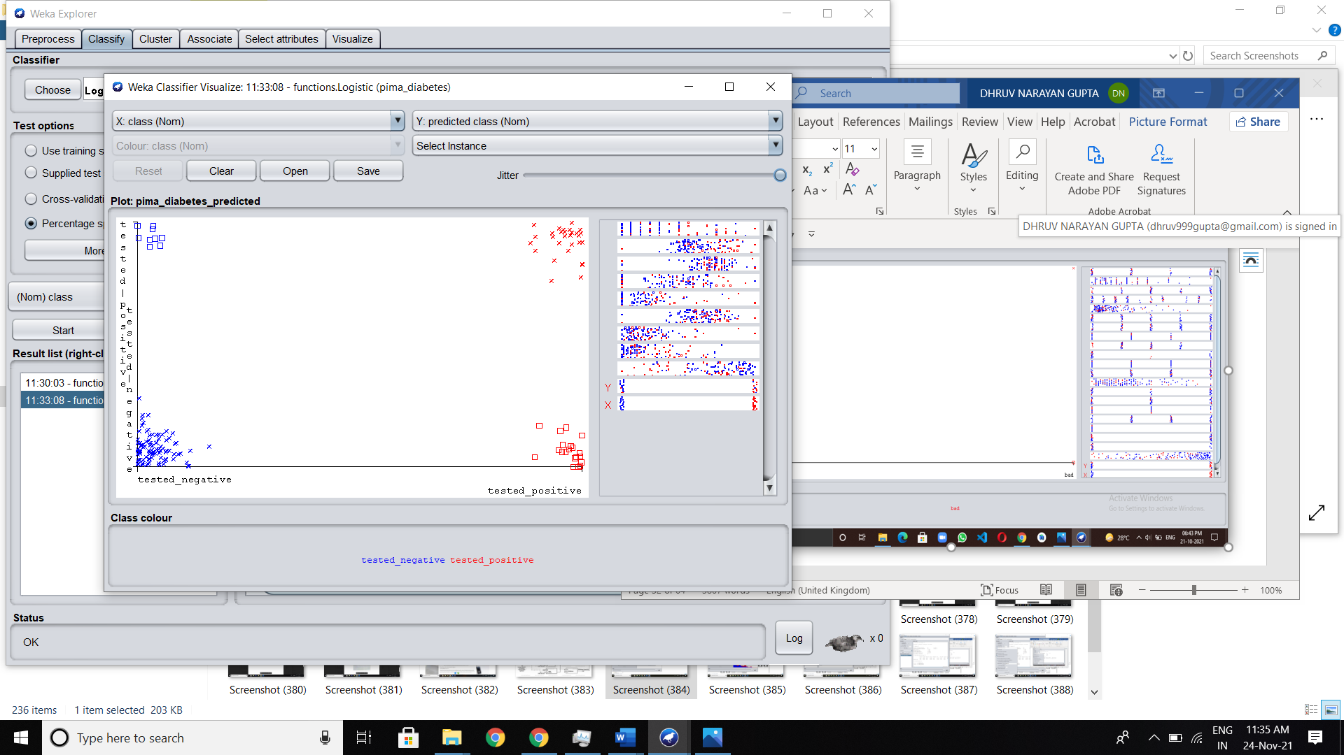

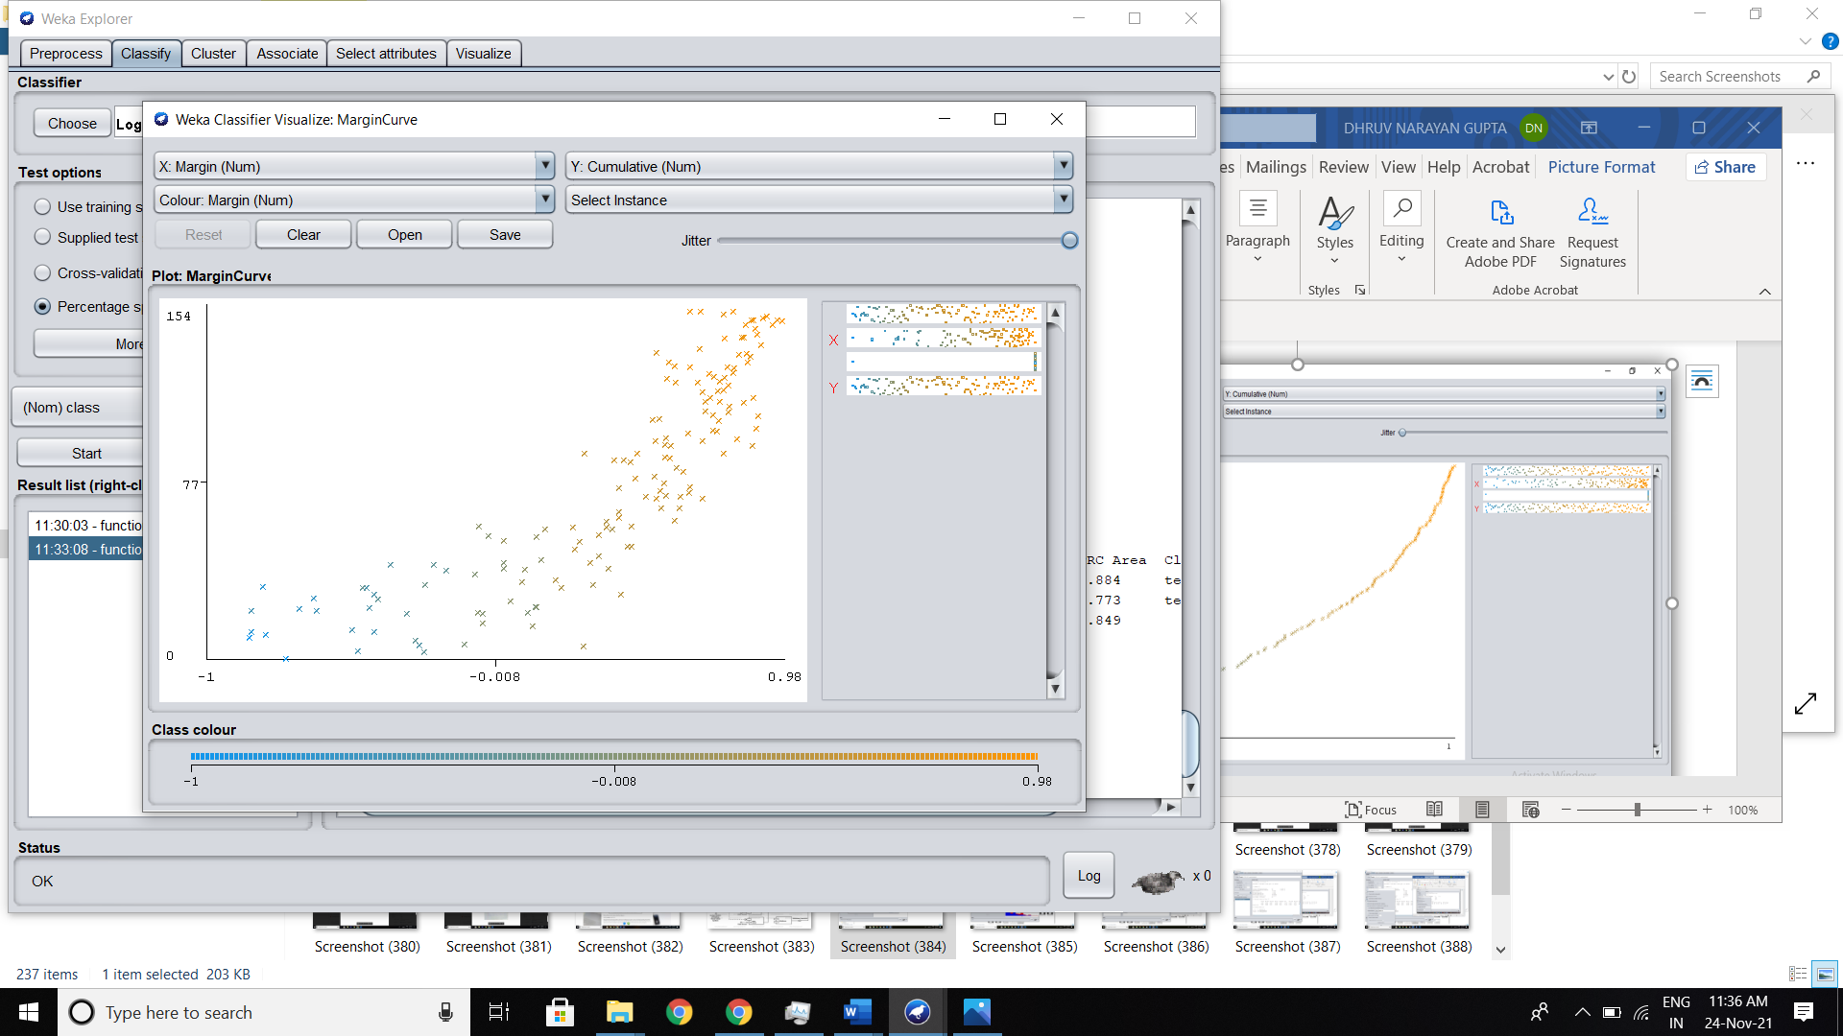

**EXPERIMENT 5**

**Execute the Naive Bayes algorithm with suitable data set and do proper analysis on the result.**

**Theory:**

**Naive Bayes Algorithm:** It is a supervised learning algorithm, which is based on Bayes theorem and used for solving classification problems. ... Naïve Bayes Classifier is one of the simple and most effective Classification algorithms which helps in building the fast machine learning models that can make quick predictions.

**Naive Bayes dataset:**

Naive Bayes classifiers are a **collection of classification algorithms based on Bayes' Theorem**. It is not a single algorithm but a family of algorithms where all of them share a common principle, i.e. every pair of features being classified is independent of each other.

**Applying Naive Bayes Algorithm in WEKA:**

**Step by step procedure for 80% Training set and 20% Testing-**

**Step 1-**

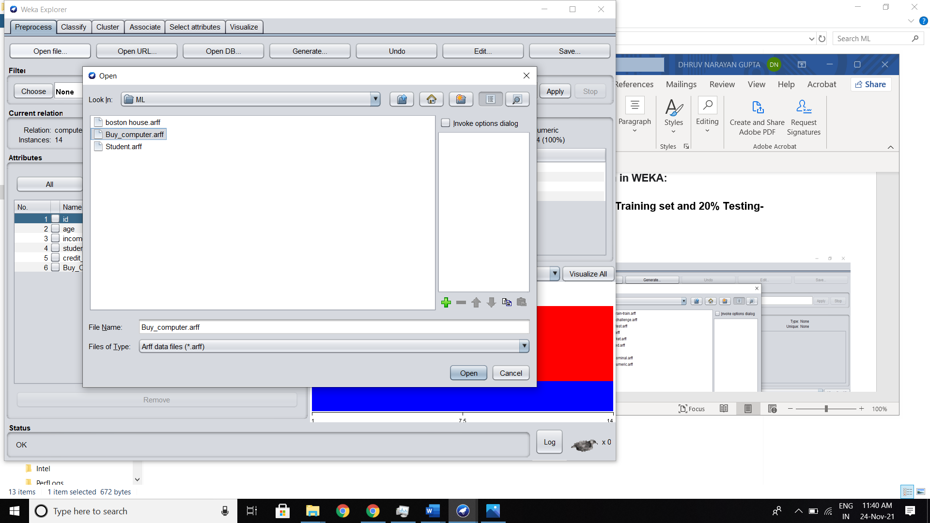

**Step 2-**

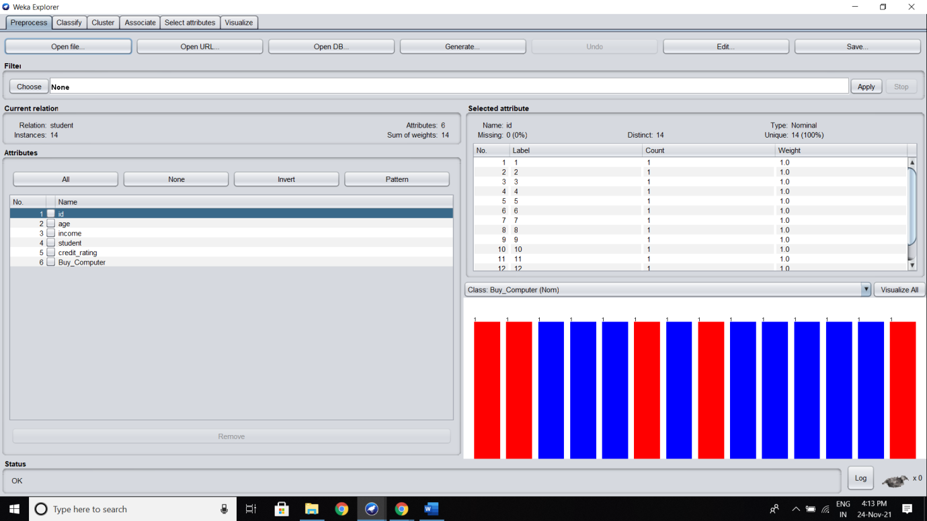

**Step 3-**

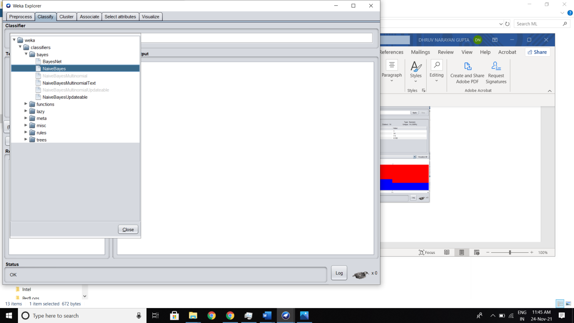

**Step 5**

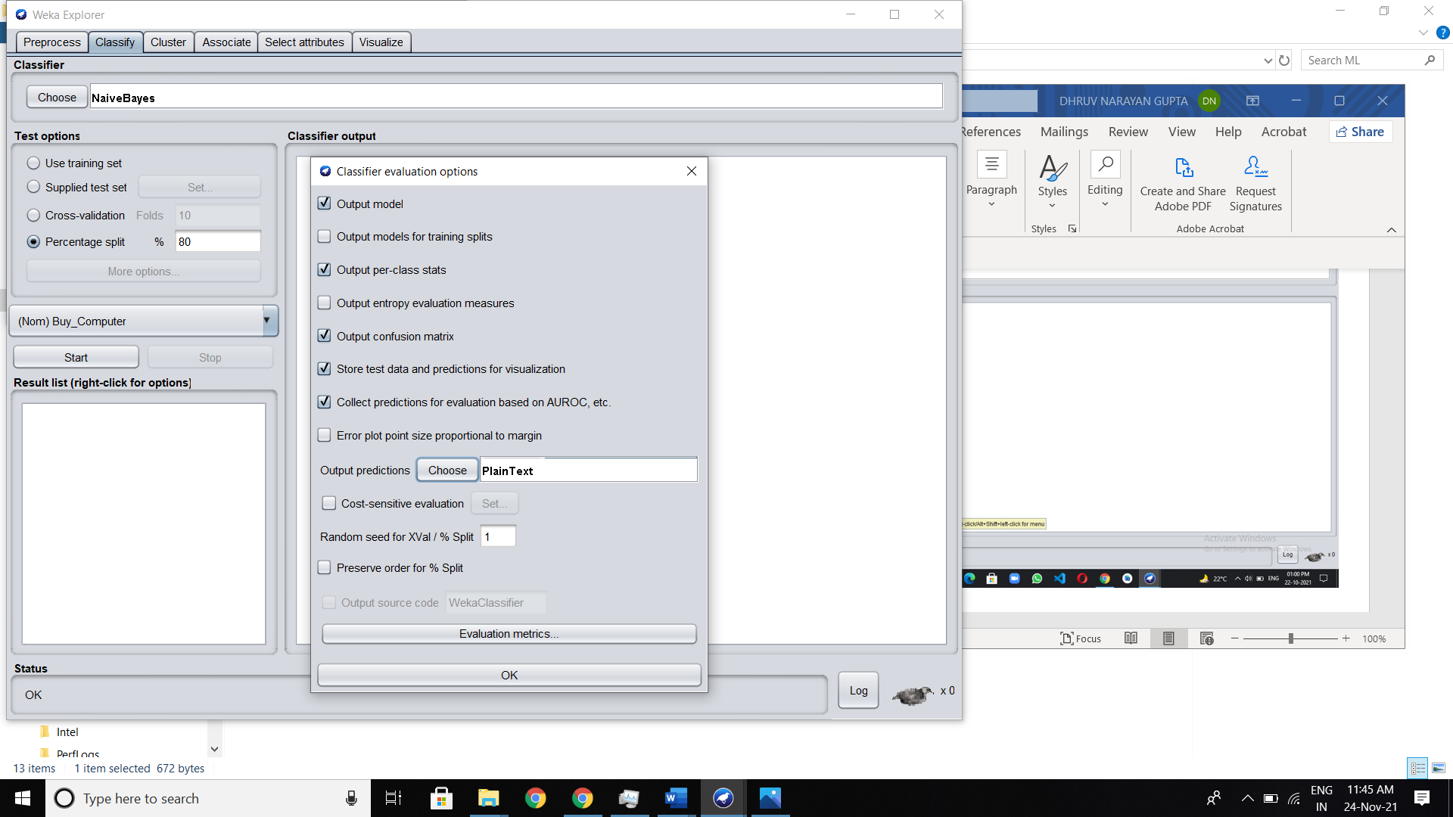

**Output -** After clicking on the Start button we get output

**For percentage split 80%:**

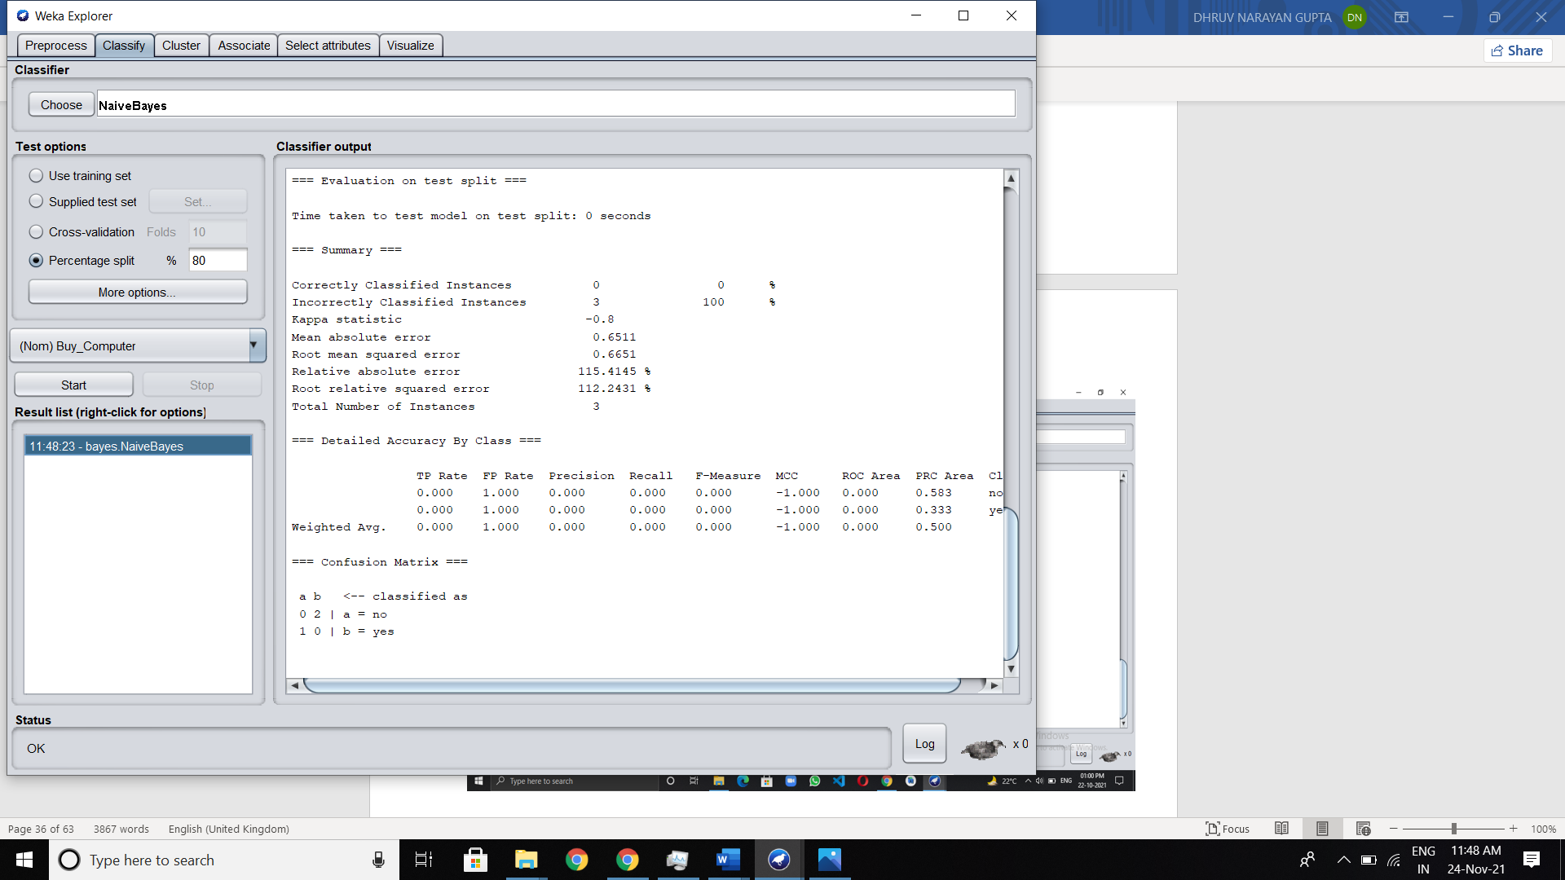

**For 10 fold cross validation:**

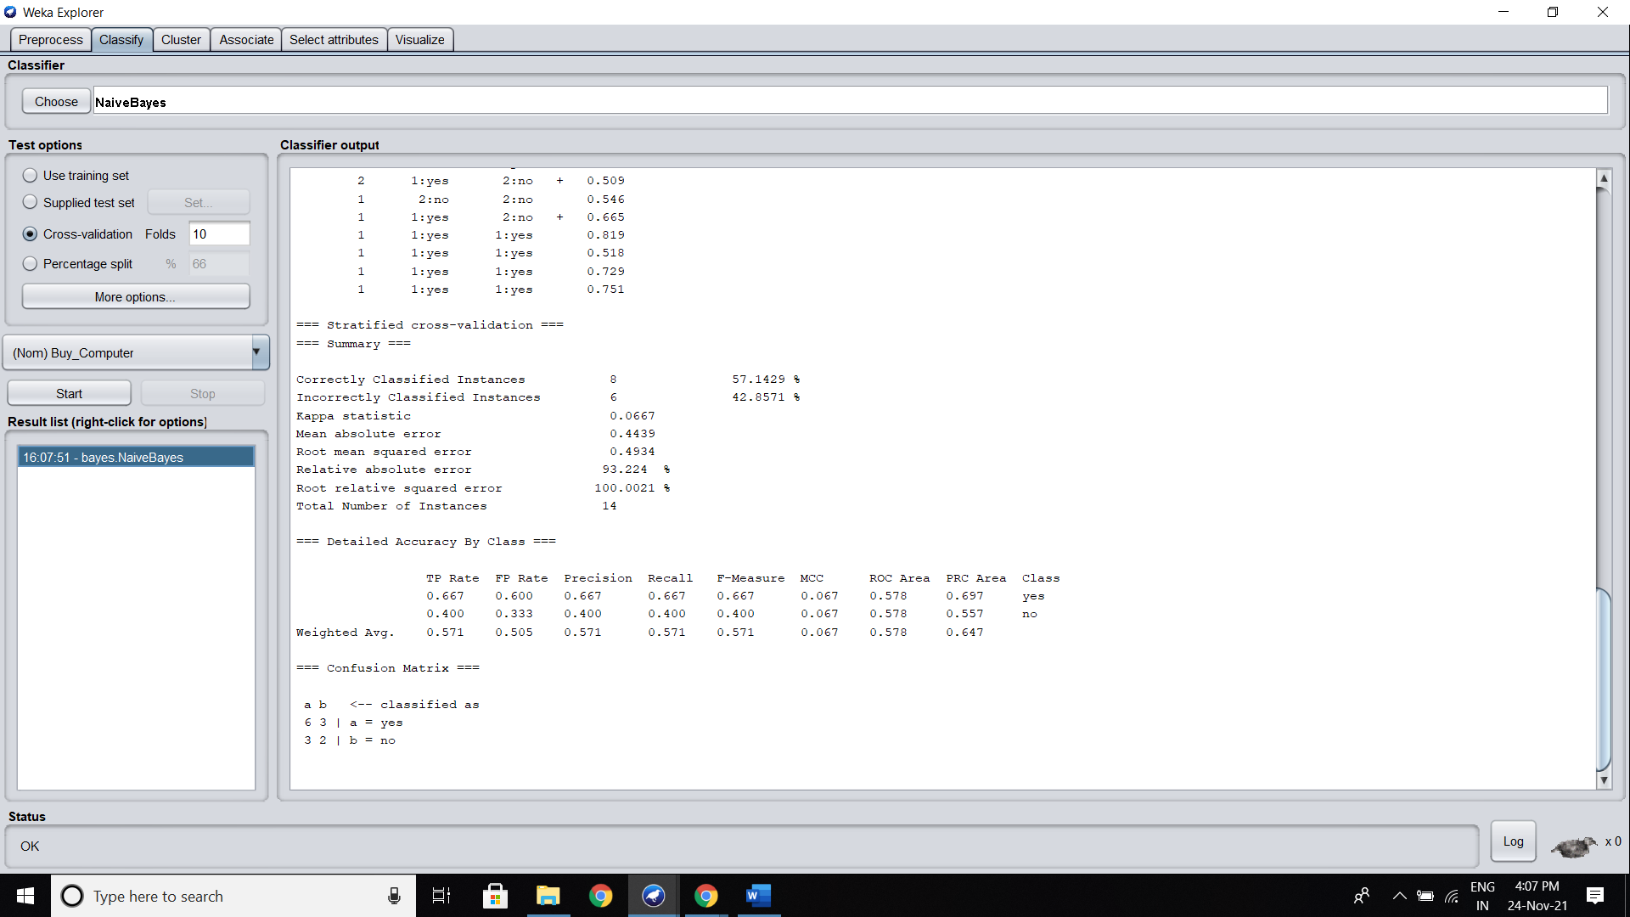

**Analyze the Result-**

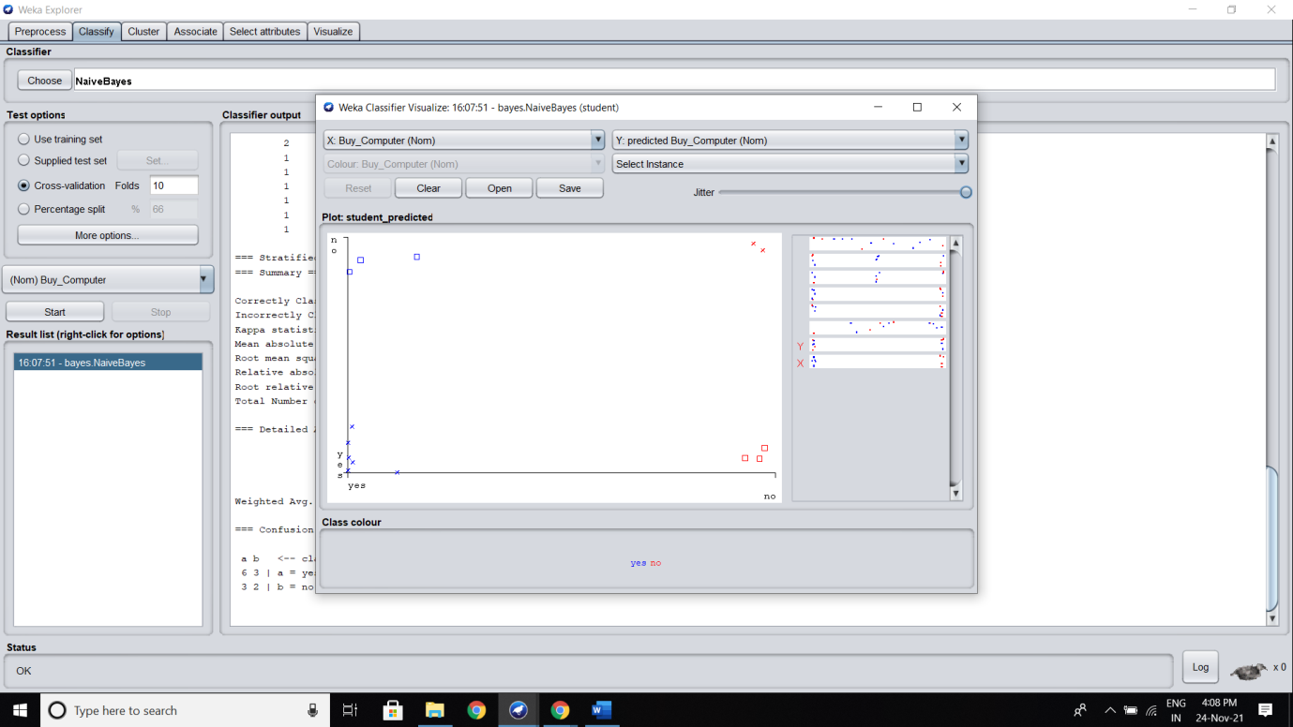

**EXPERIMENT 6**

**Identify a dataset for executing the Decision Tree algorithm to implement and analyze the same with cross-validation and percentage split.**

**Theory:**

**Decision Tree:** Introduction Decision Trees are a type of Supervised Machine Learning (that is you explain what the input is and what the corresponding output is in the training data) where the data is continuously split according to a certain parameter. The tree can be explained by two entities, namely decision nodes and leaves. The leaves are the decisions or the final outcomes. And the decision nodes are where the data is split.

**What kind of data is suitable for the decision tree?**

Decision trees are used for handling non-linear data sets effectively. The decision tree tool is used in real life in many areas, such as engineering, civil planning, law, and business. Decision trees can be divided into two types; categorical variable and continuous variable decision trees.

**Applying Decision Tree Algorithm in WEKA using J48-**

**Step 1-** Selecting iris dataset from WEKA data-

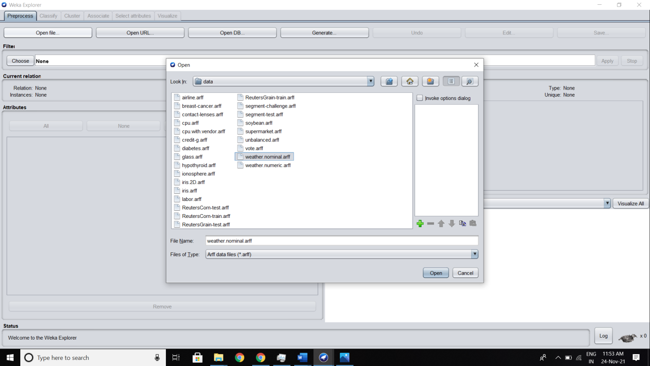

**Step 2-**

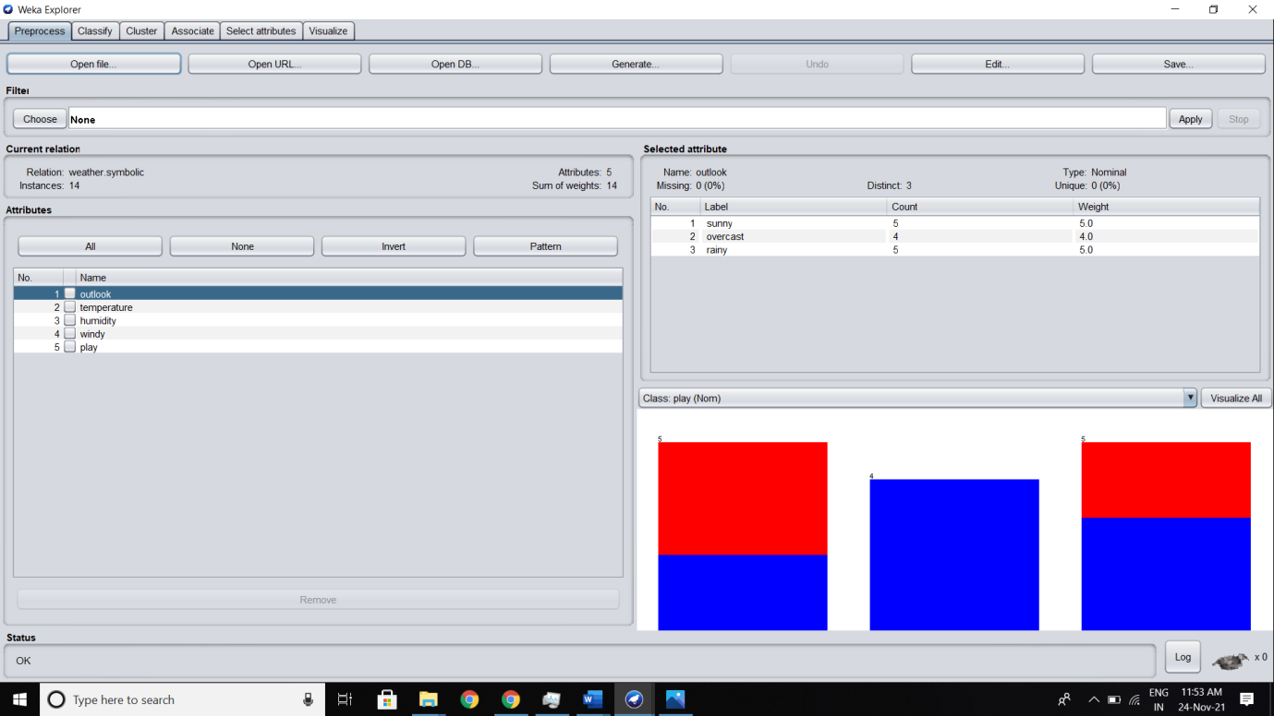

**Step 3-**

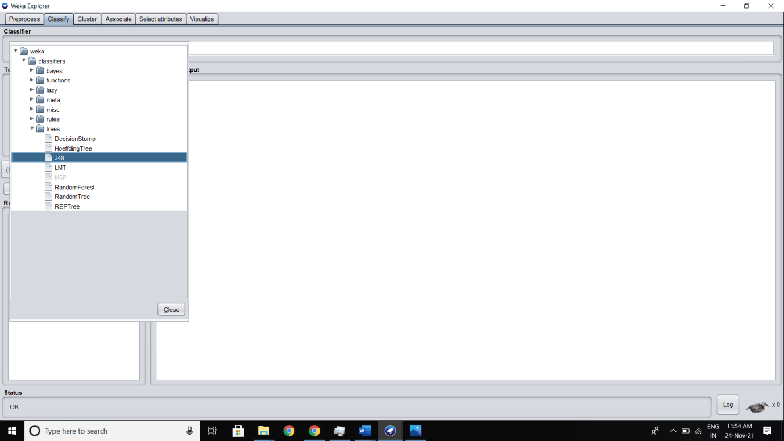

**Applying J48 using Cross-Validation-**

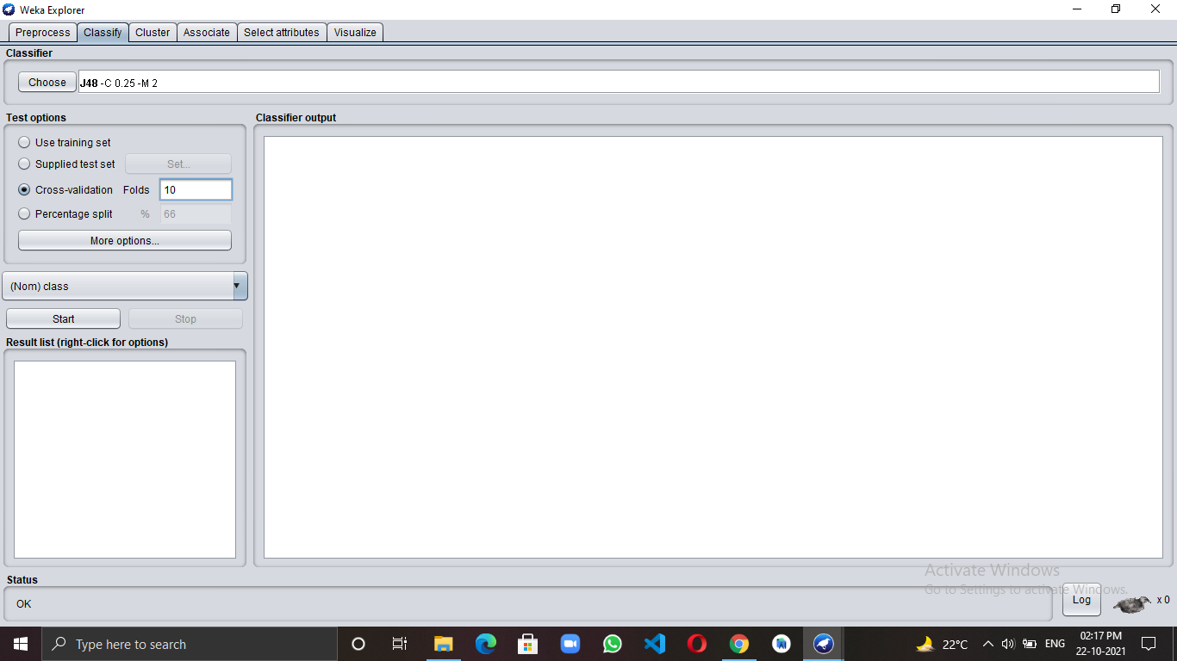

**Output -** After clicking on the Start button we get output

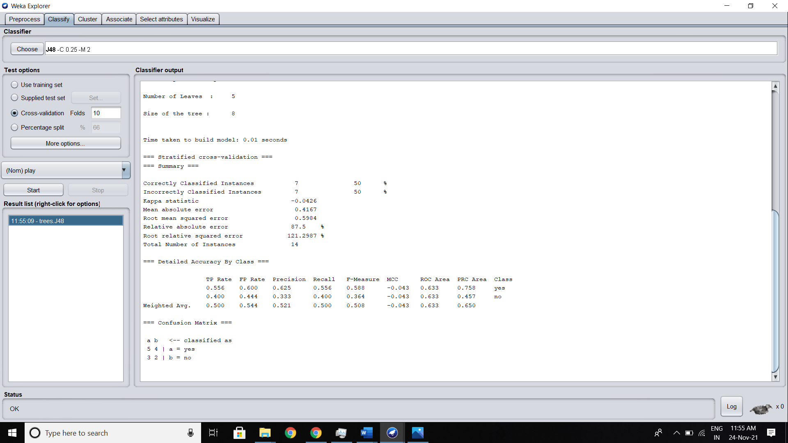

**Analyze the Result-**

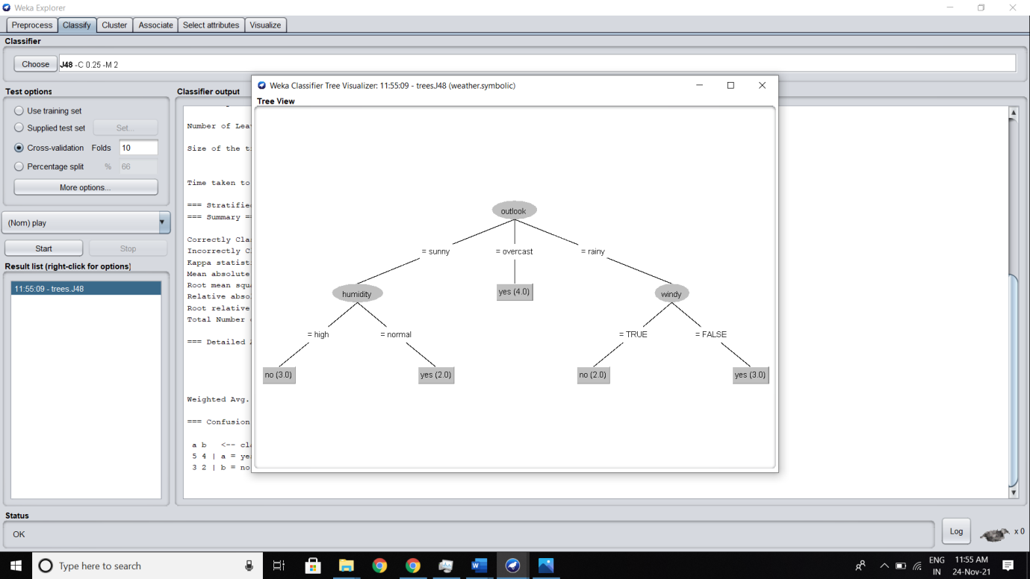

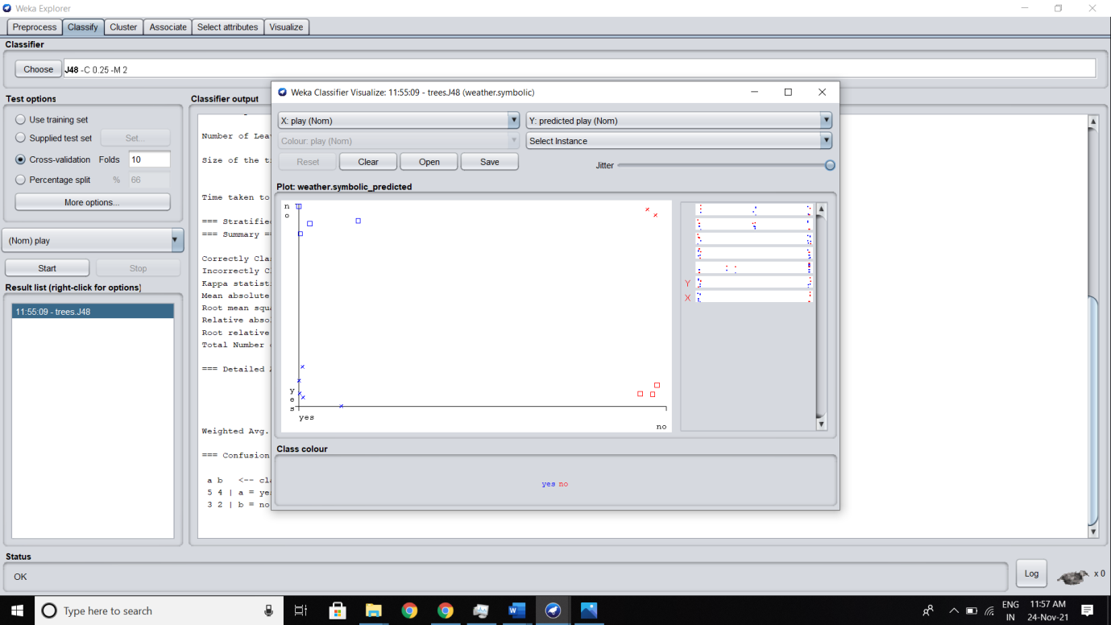

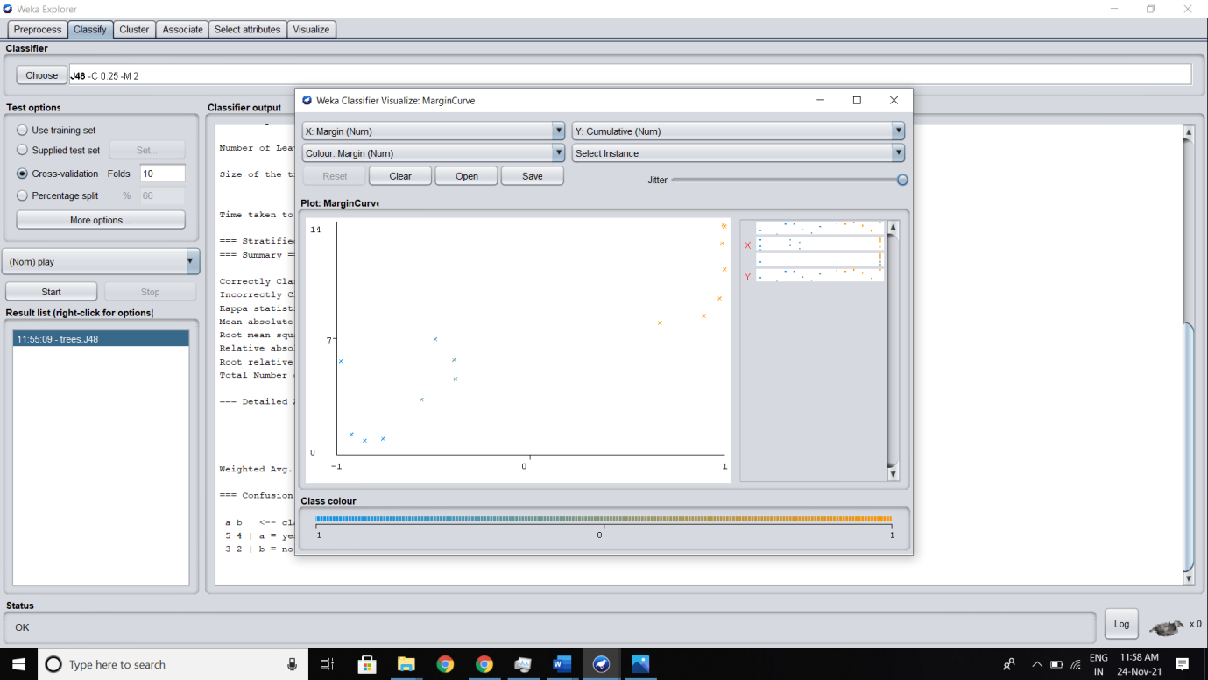

**Applying J48 using Percentage-Split with 80% Training and 20% Testing-**

Select Percentage split option and write 80% inbox-

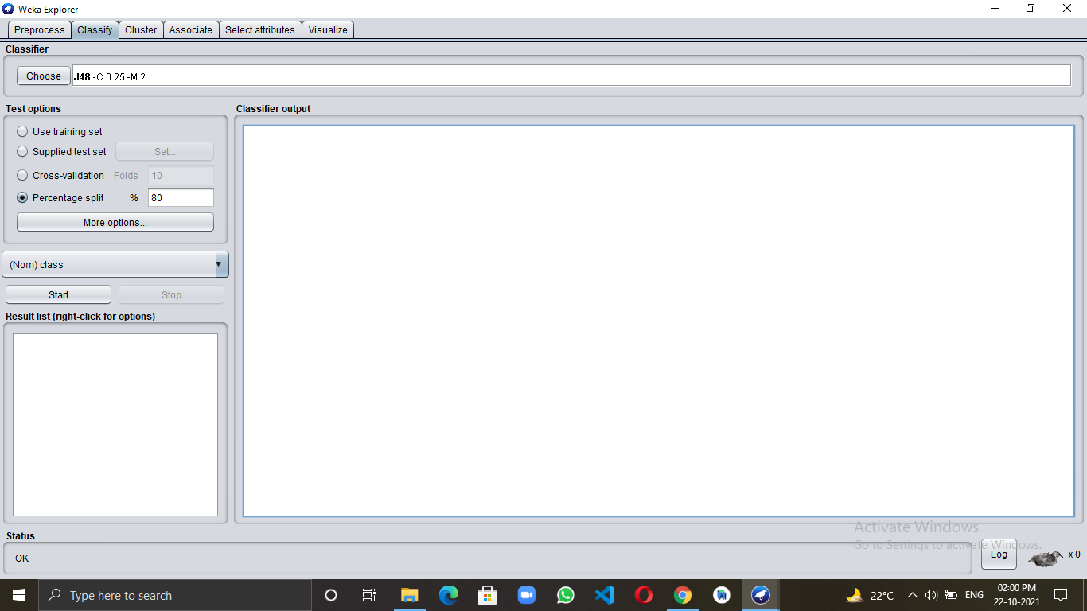

**Output -** After clicking on the Start button we get output

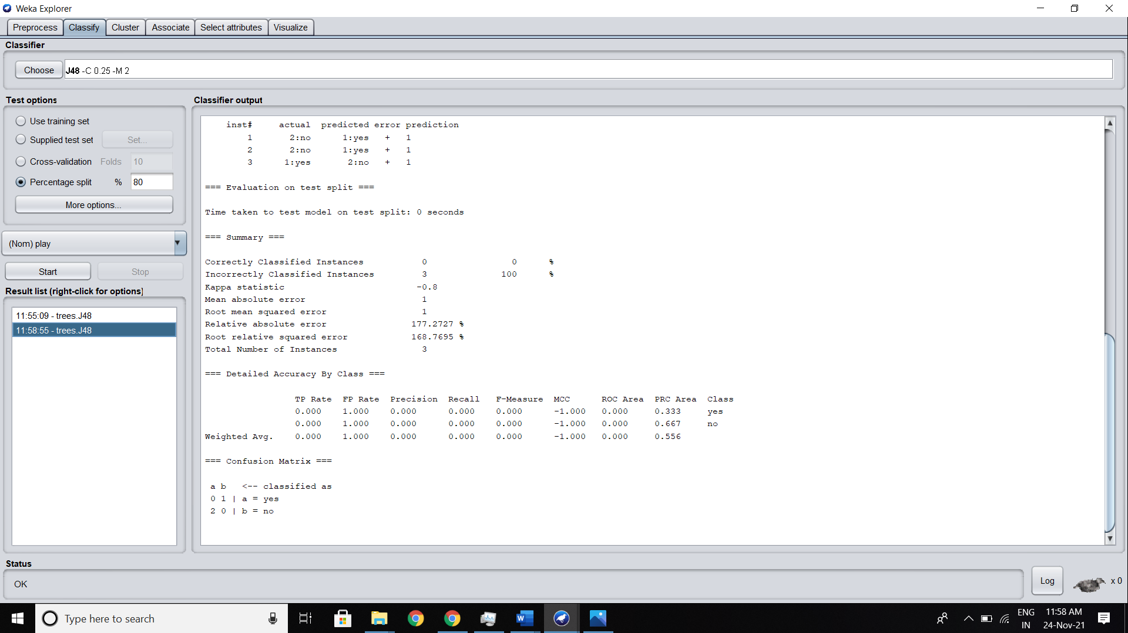

**Analyze the Result-**

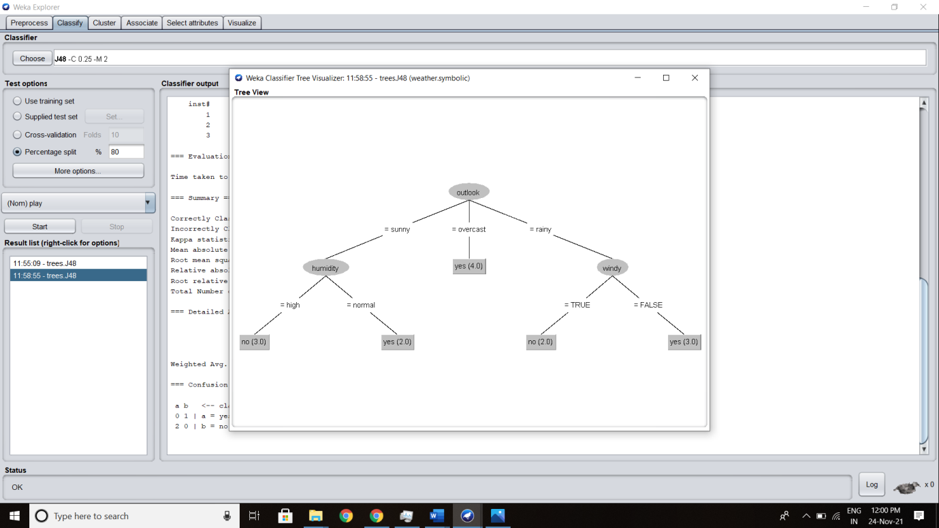

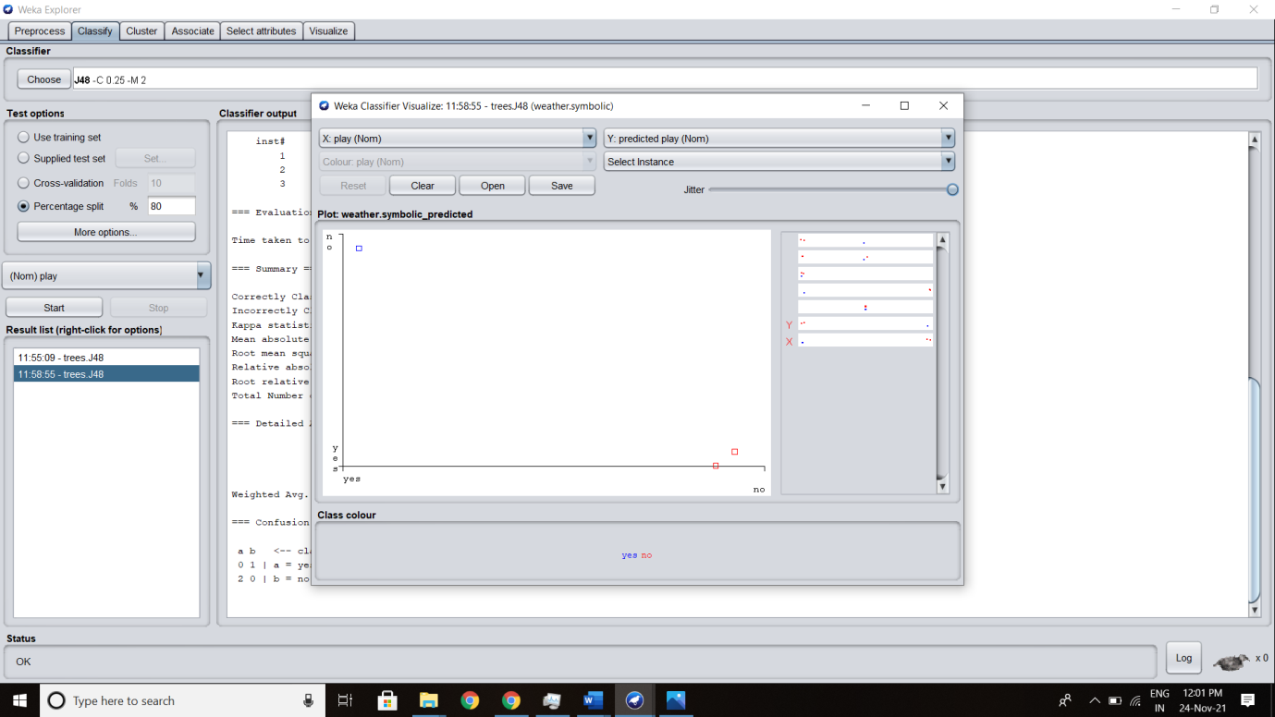

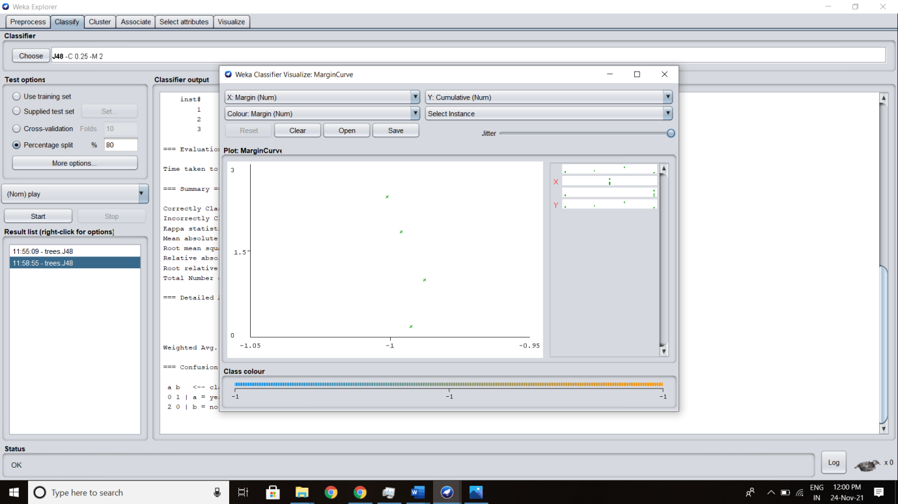

**EXPERIMENT 7**

**Identify a dataset for executing the Support Vector Machine algorithm and do the proper analysis with different test options.**

**Theory:**

**Support Vector Machine Algorithm:**

“Support Vector Machine” (SVM) is a supervised [machine learning algorithm](https://courses.analyticsvidhya.com/courses/introduction-to-data-science-2?utm_source=blog&utm_medium=understandingsupportvectormachinearticle) that can be used for both classification or regression challenges. However, it is mostly used in classification problems. In the SVM algorithm, we plot each data item as a point in n-dimensional space (where n is a number of features you have) with the value of each feature being the value of a particular coordinate. Then, we perform classification by finding the hyper-plane that differentiates the two classes very well (look at the below snapshot).

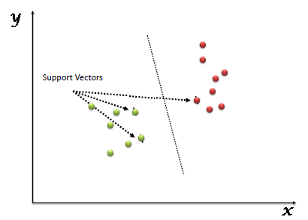

Support Vectors are simply the coordinates of individual observation. The SVM classifier is a frontier that best segregates the two classes (hyper-plane/ line).

**DATASET:**

The dataset we will be using to implement our SVM algorithm is the Iris dataset. You can select it from the data folder of WEKA. Since the Iris dataset has three classes, we will remove one of the classes. This leaves us with a binary class classification problem.

**Step by Step Procedure for Applying Support Vector Machine Algorithm in WEKA using SMO-**

**Step 1-** we opened file iris from the data folder provided in WEKA

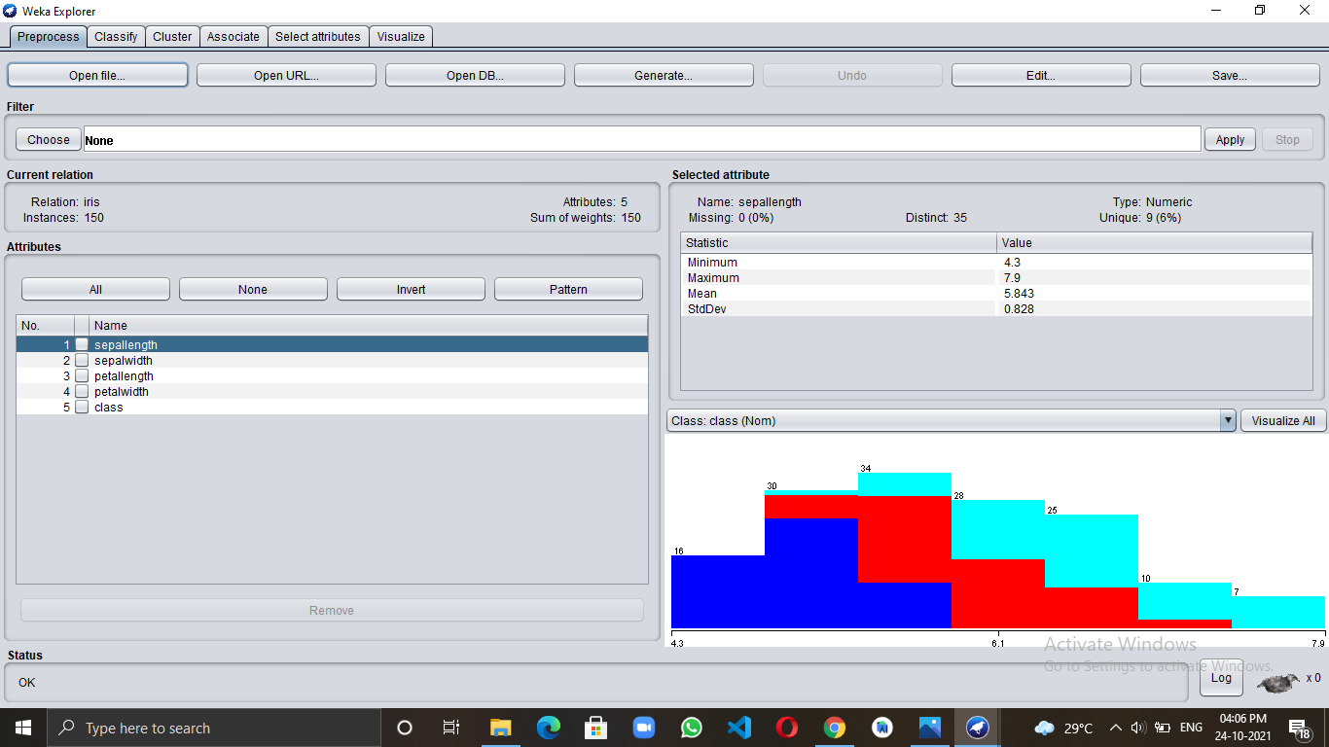

**Step 2-**

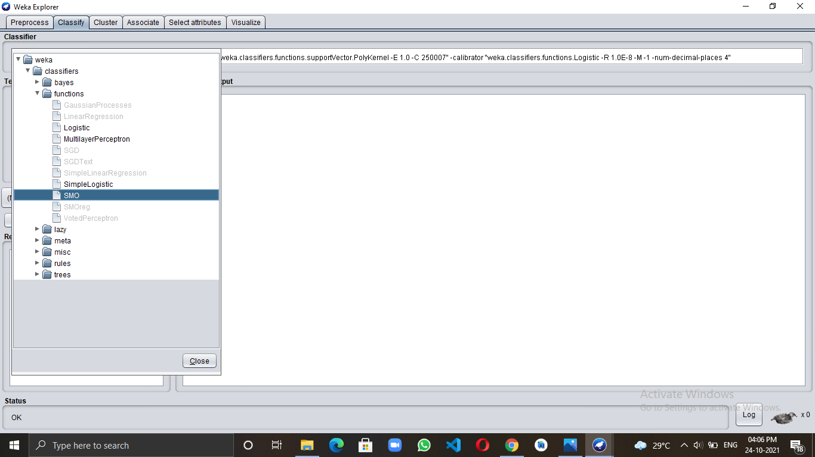

**Applying SMO using Cross-Validation-**

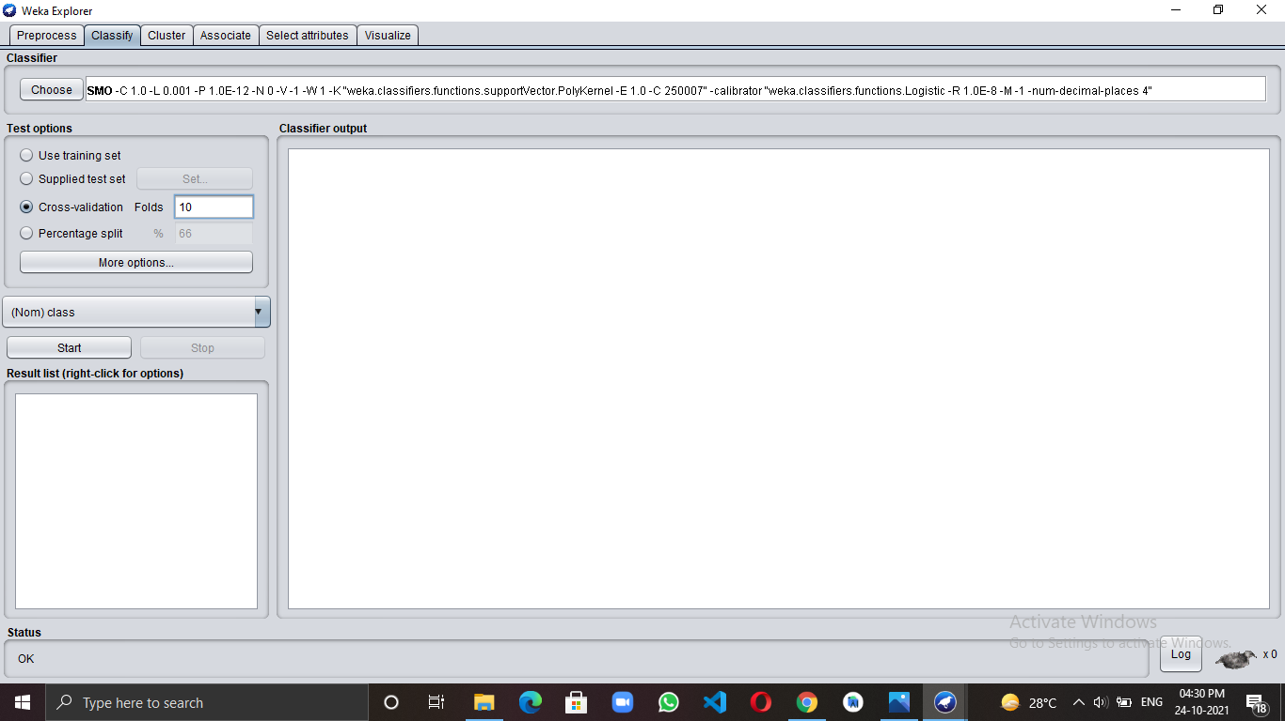

**Output -** After clicking on the Start button we get output

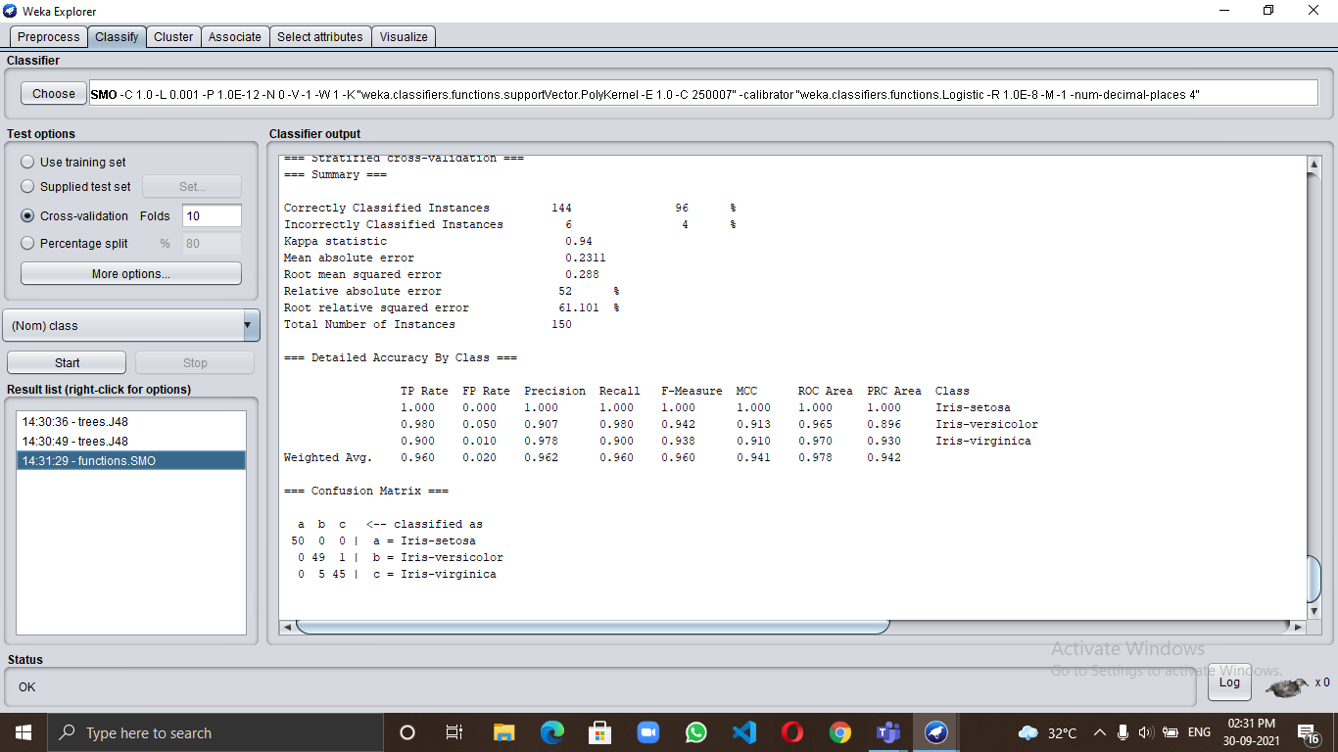

**Analyze the Result-**

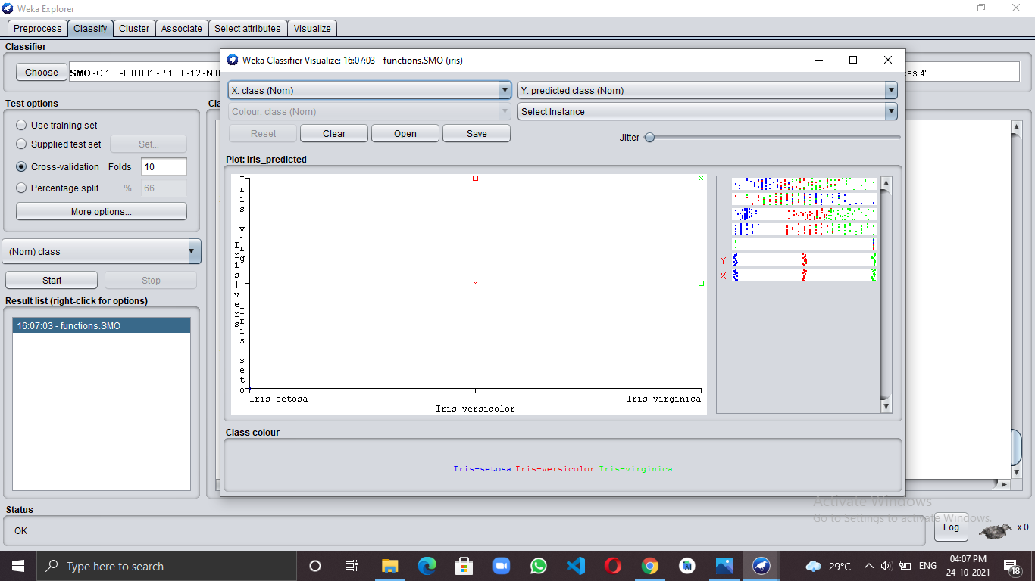

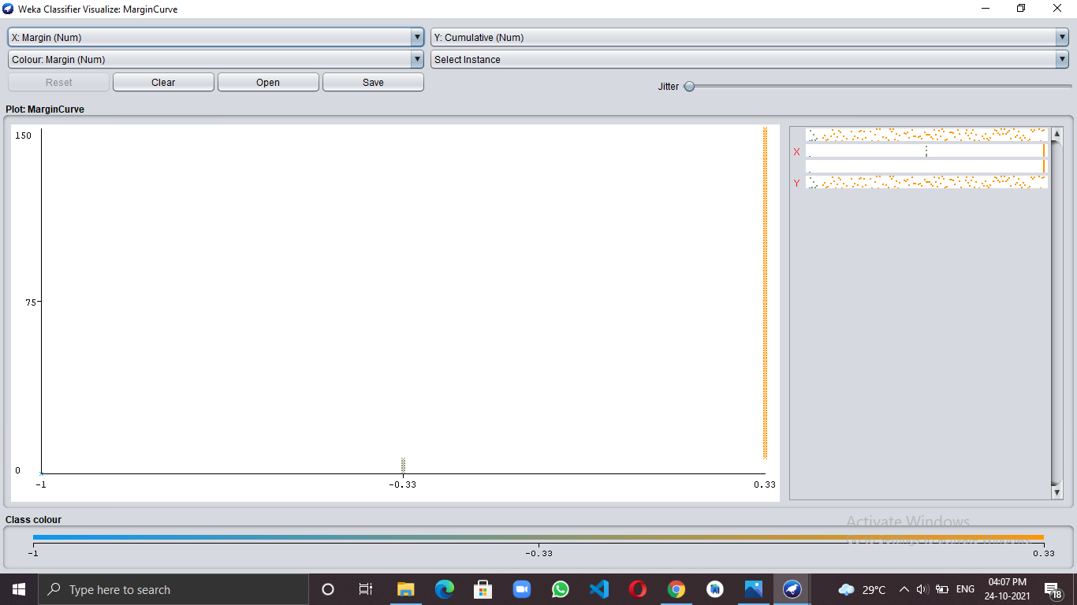

**Applying SMO using Percentage-Split with 80% Training and 20% Testing-**

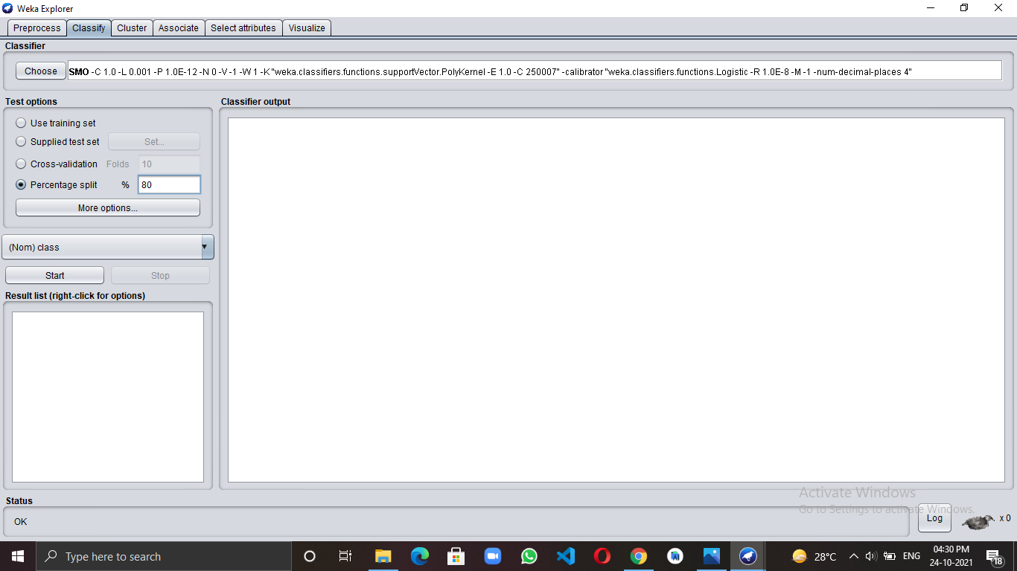

**Output -** After clicking on the Start button we get output

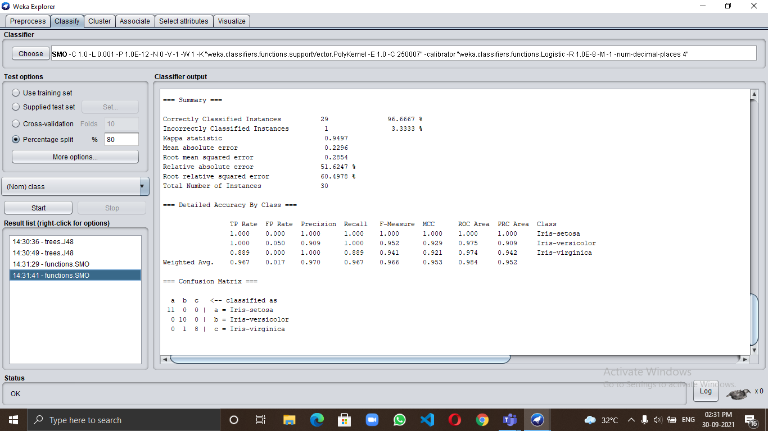

**Analyze the Result-**

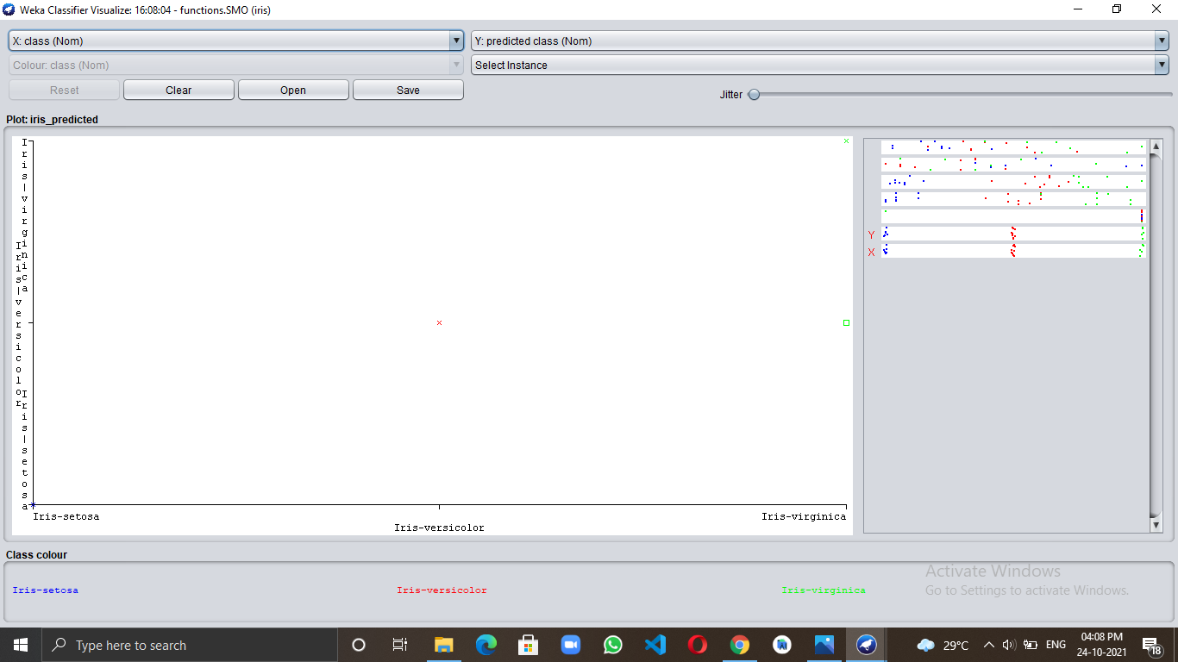

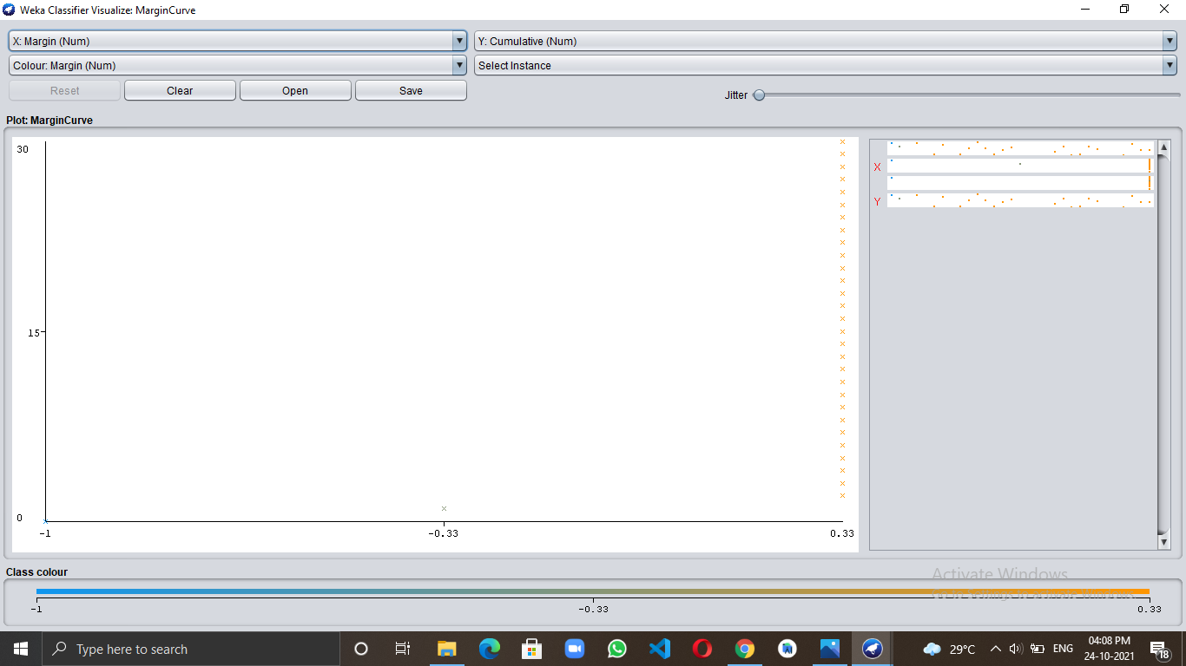

**EXPERIMENT 8**

**Identify a dataset for applying filters such as removing missing values and normalizing data**

**value. Analyse the results.**

**Theory:**

Missing value analysis helps address several concerns caused by incomplete data. If cases with missing values are systematically different from cases without missing values, the results can be misleading. Also, missing data may reduce the precision of calculated statistics because there is less information than originally planned. Another concern is that the assumptions behind many statistical procedures are based on complete cases, and missing values can complicate the theory required.

**Simple logistic regression:**

Simple logistic regression **assumes that the observations are independent**; in other words, that one observation does not affect another. ... Simple logistic regression assumes that the relationship between the natural log of the odds ratio and the measurement variable is linear.

**Normalization:**

Normalization is a technique often applied as part of data preparation for machine learning. The goal of normalization is to **change the values of numeric columns in the dataset** to use a common scale, without distorting differences in the ranges of values or losing information

**Selecting vote.arff dataset from data folder provided by WEKA for applying Removing missing values**

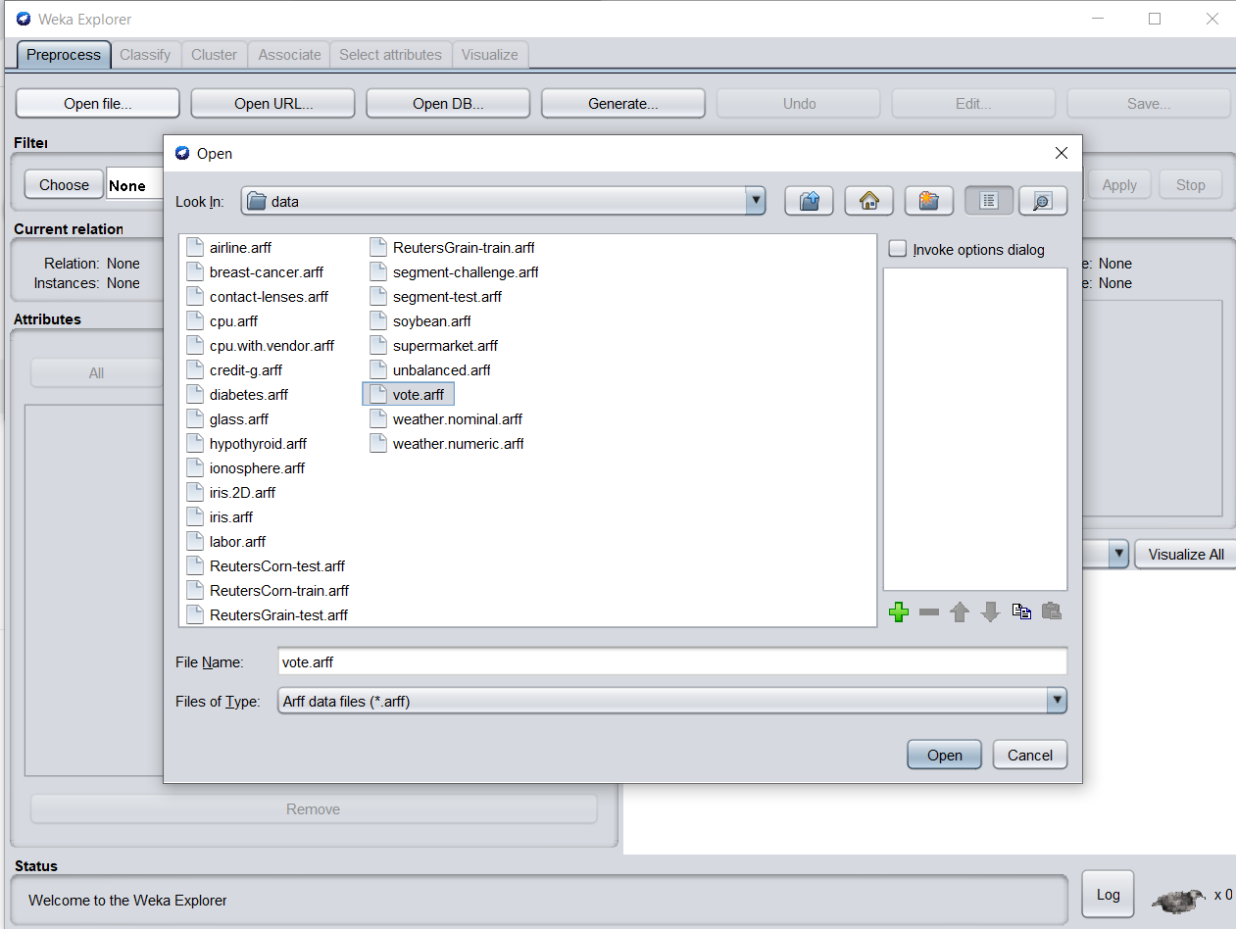

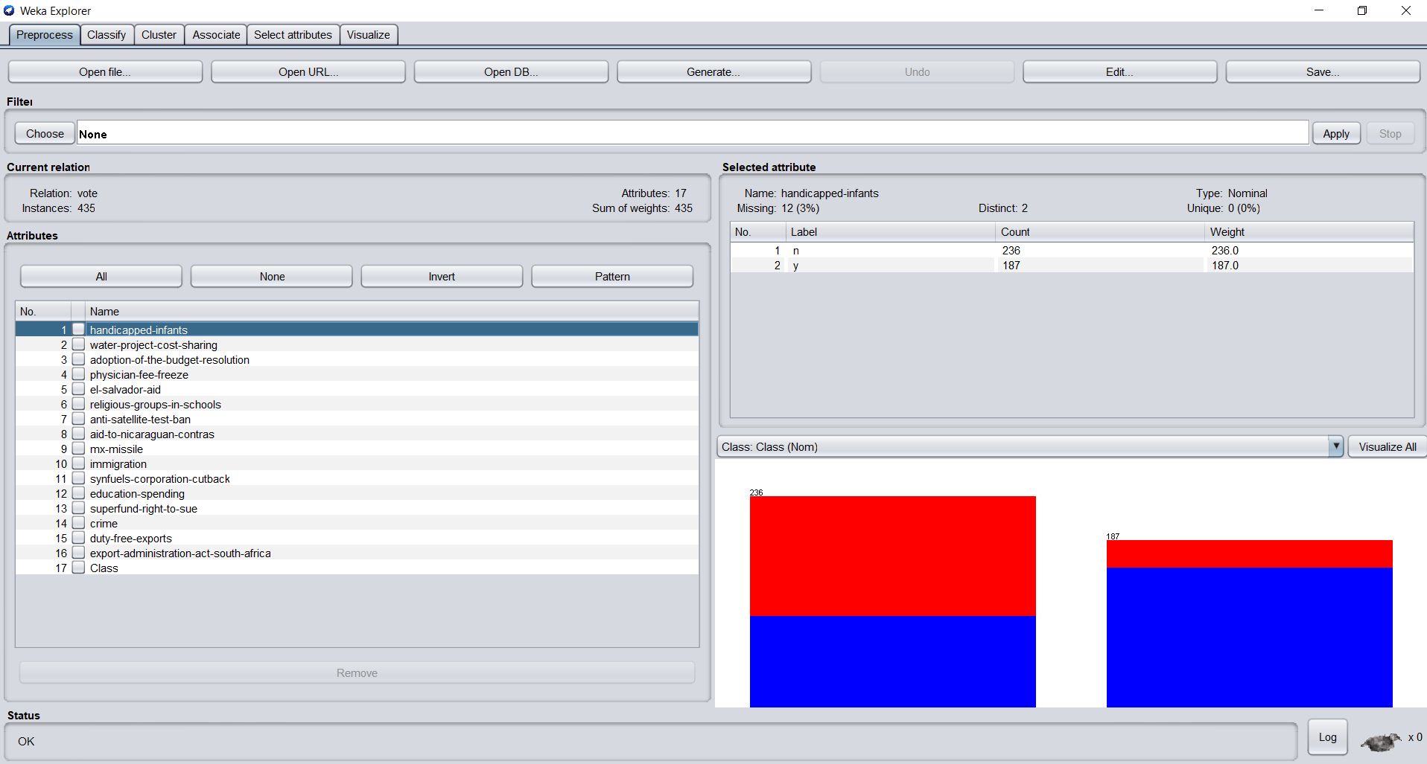

**Before applying filter**

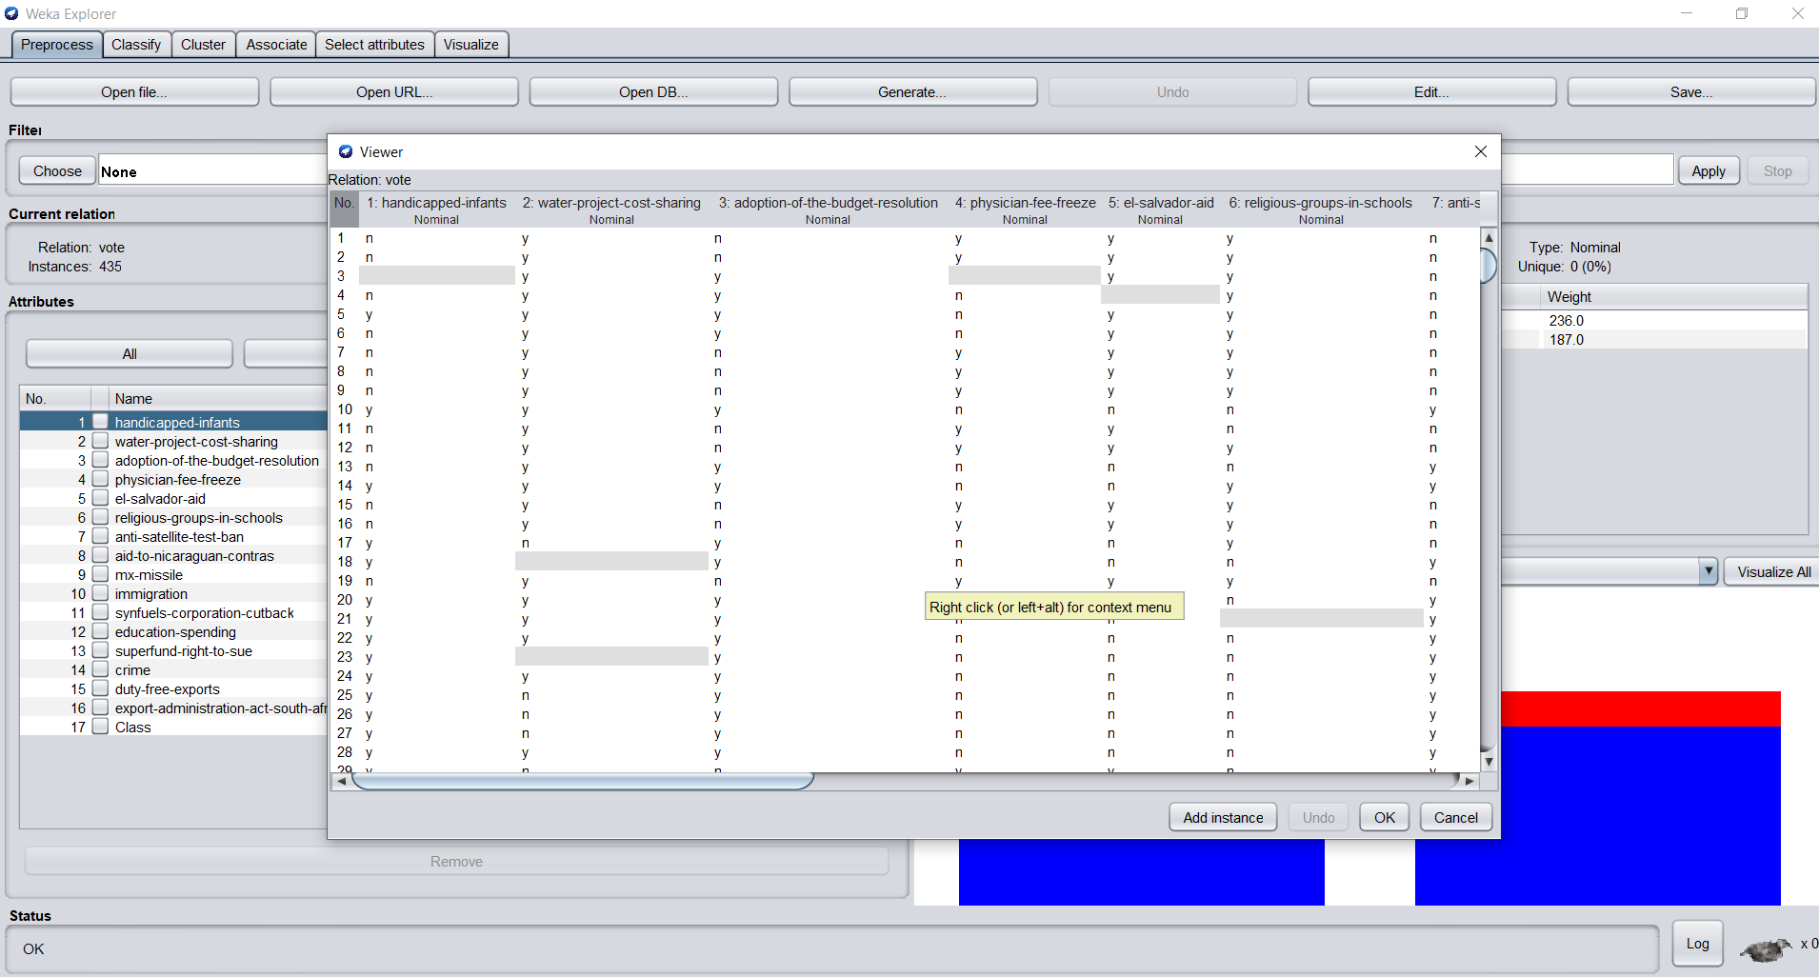

**Choose filter : Filter>Unsupervised>Attribute>ReplaceMissingValues.**

**After applying filter**

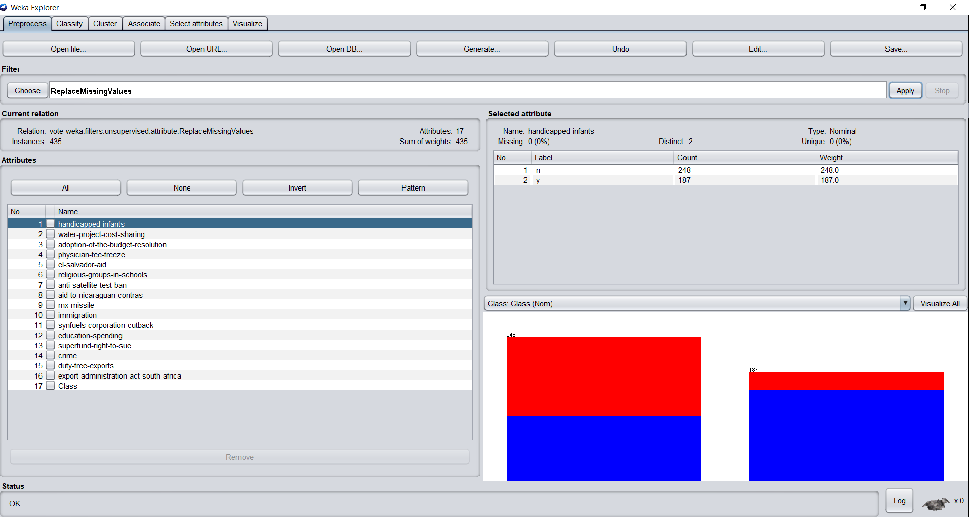

**Result analysis:** 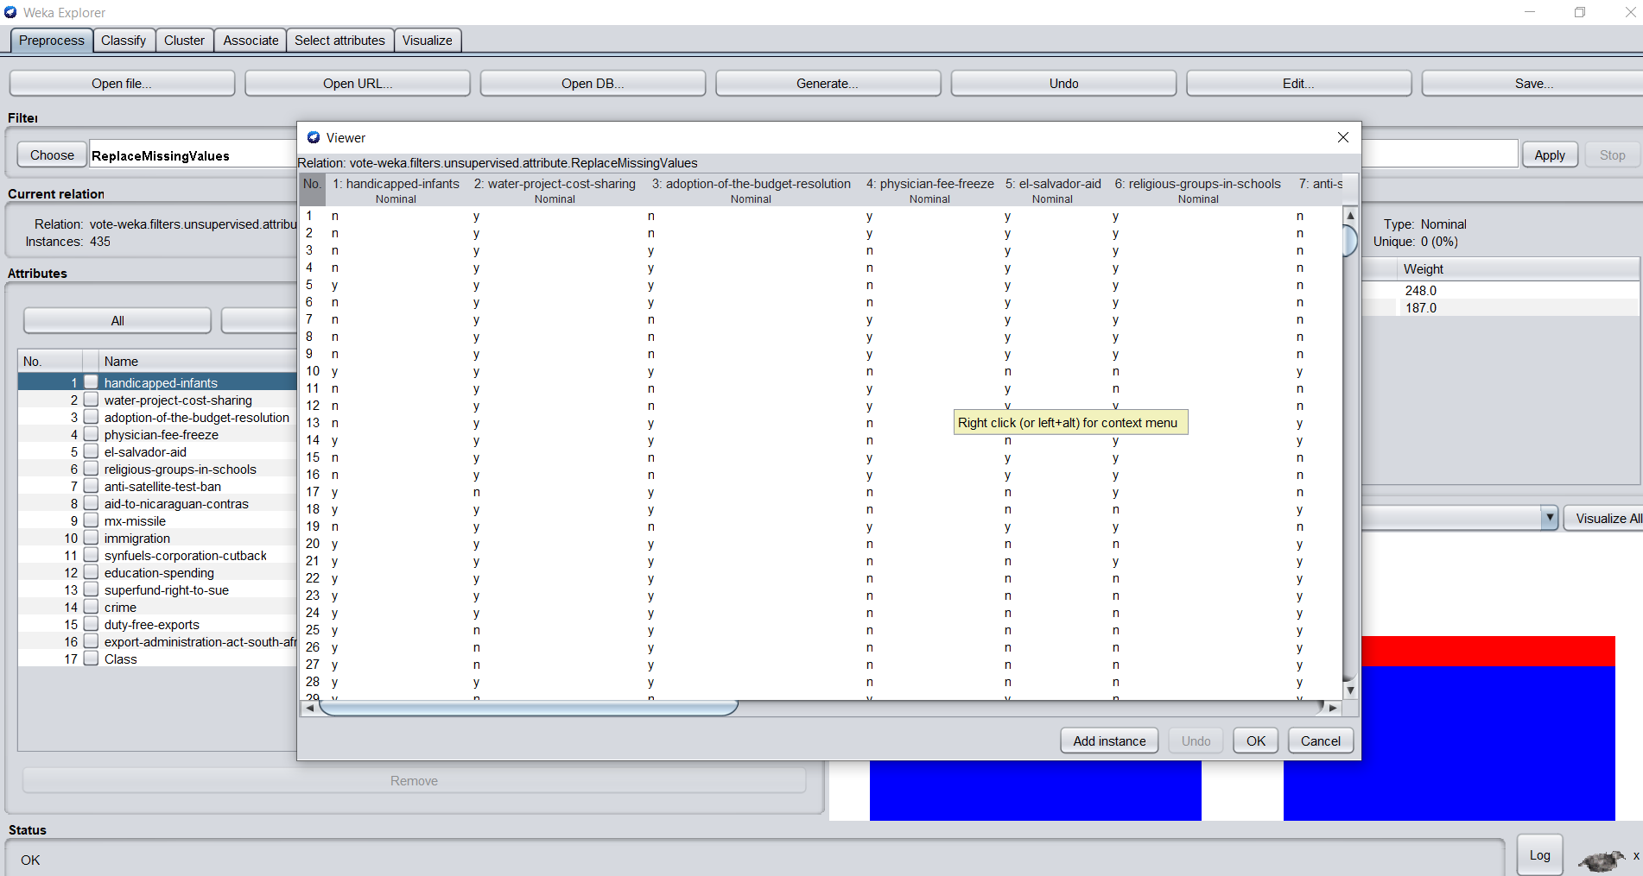

The missing values have been replaced resulting in improved accuracy.

**Improved accuracy**

With 10 fold cross validation

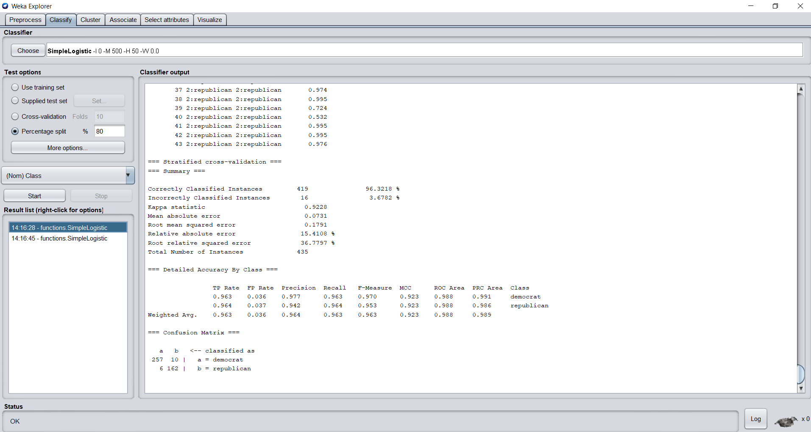

With 80:20 split percentage

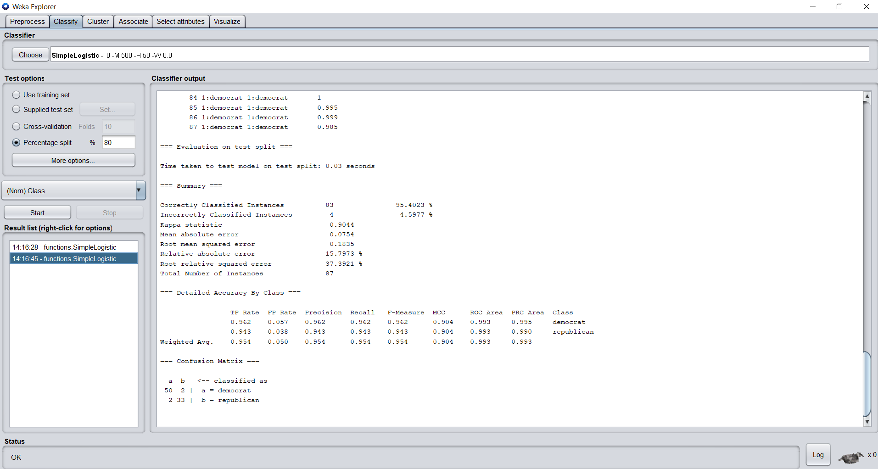

**Selecting iris.arff dataset from data folder provided by WEKA for applying Normalization**

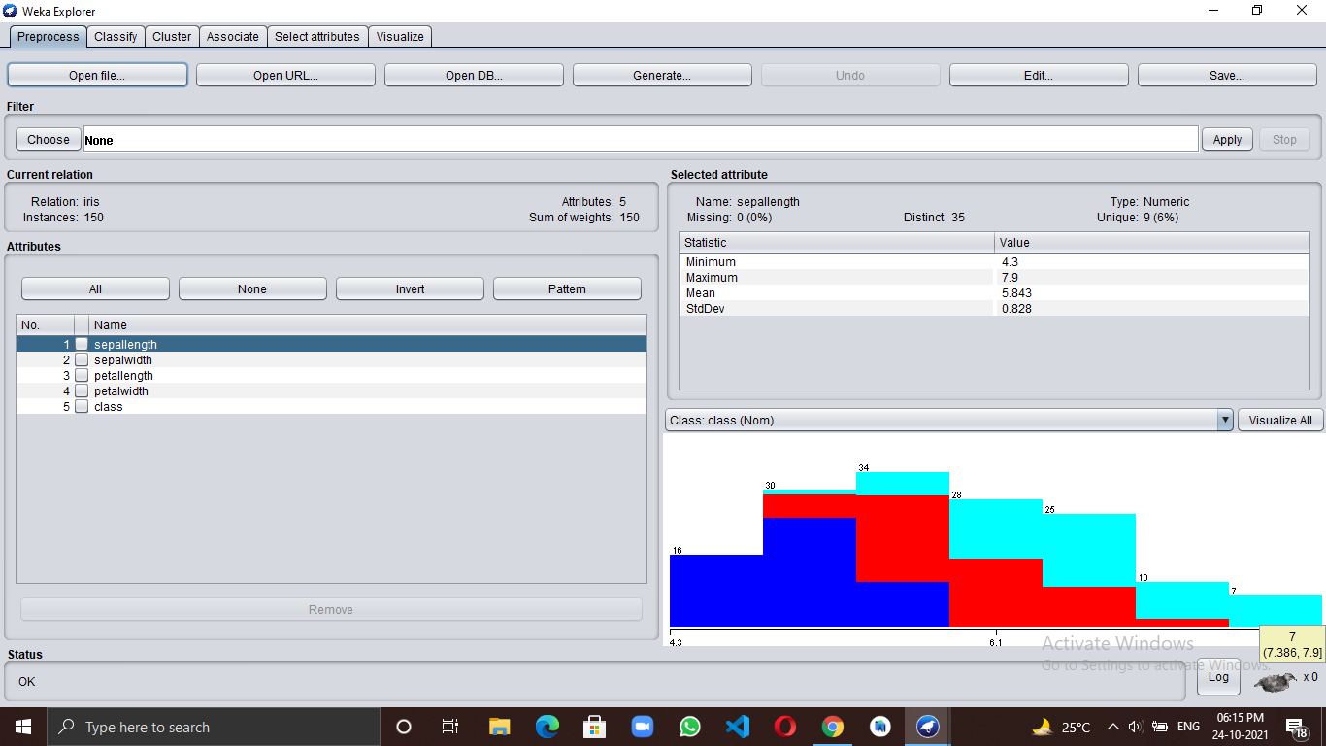

**Applying normalisation on iris dataset-**

Filter>Unsupervised>Attribute>Normalize.

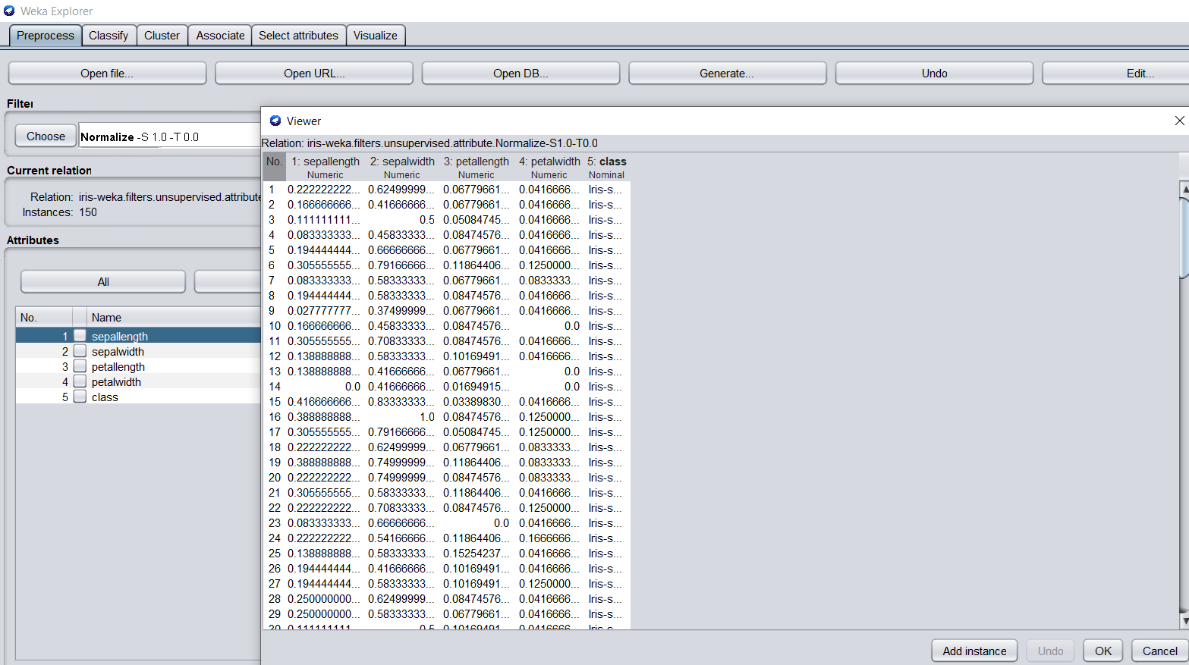

**Applying Naive bayes Classifier on iris dataset after normalization-**

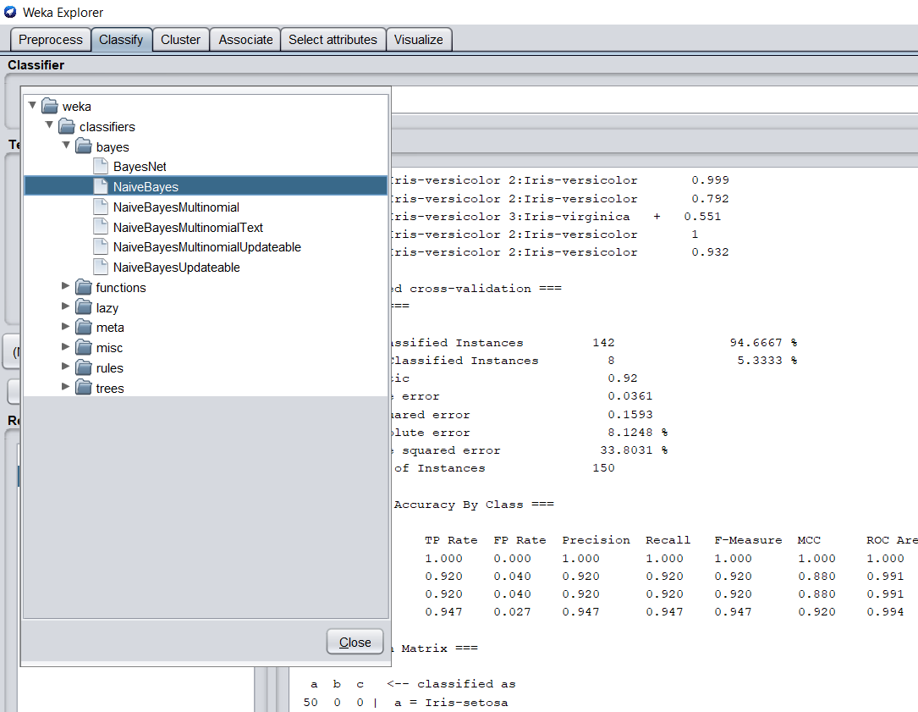

**Analyze the result-**

On applying naive bayes classifier on the iris dataset without using Normalize filter we get accuracy = 96% but on applying Naive bayes Classifier on the normalized iris dataset we get accuracy = 94.6667 % . We can observe that Normalize filter increases the performance of Naive bayes Classifier in this case but decreased the accuracy because the data set was itself normalized. In this way we can use this filter on any dataset whose performance will increase on applying algorithms.

Before Normalization

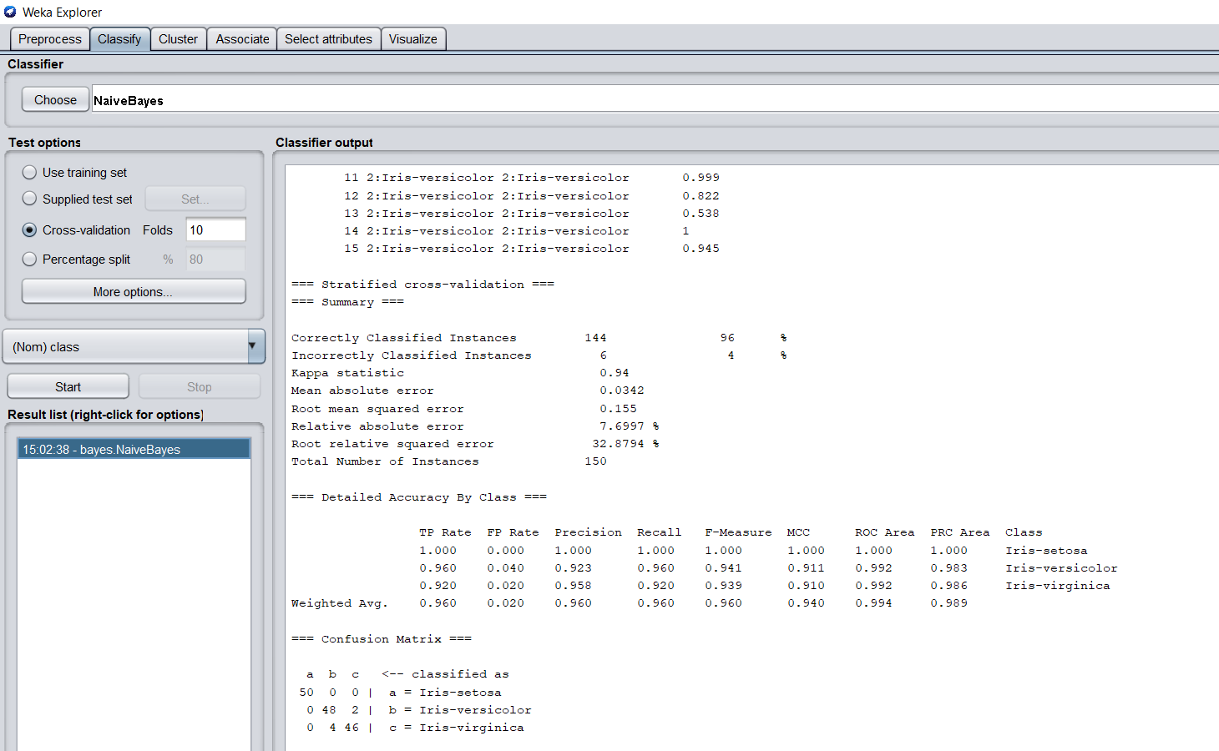

After normalization

10 fold cross validation

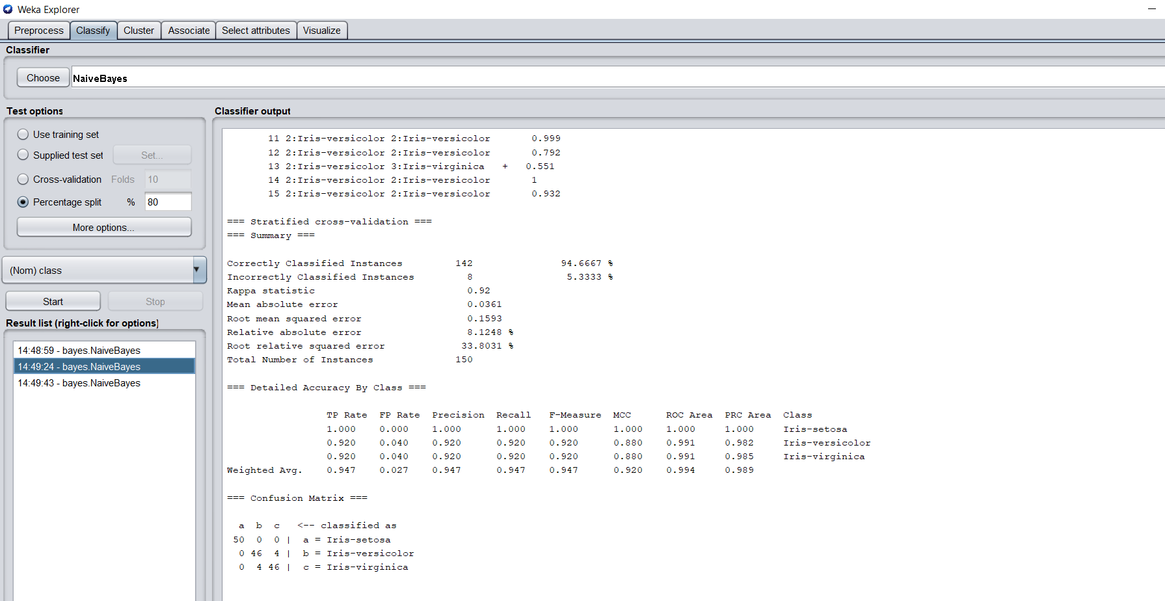

80% split percentage

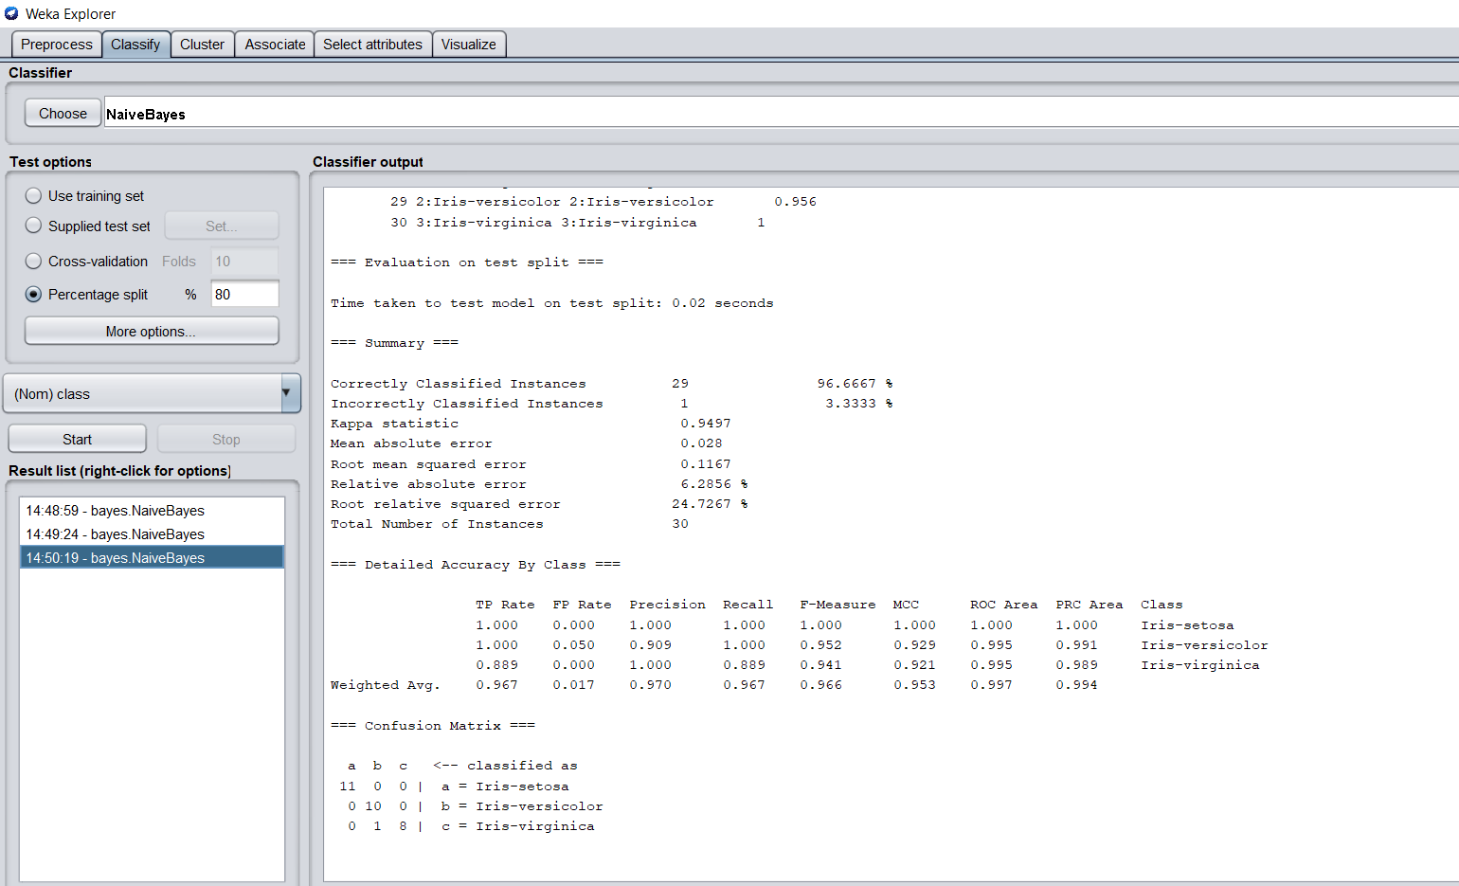

**EXPERIMENT 9**

**Identify/prepare a dataset for executing the K-Means algorithm. Do the proper analysis of the result by visualizing the clusters and by changing the K.**

**Theory:**

**K-Means Algorithm:**

Kmeans algorithm is an iterative algorithm that tries to partition the dataset into Kpre-defined distinct non-overlapping subgroups (clusters) where each data point belongs to only one group. ... Keep iterating until there is no change to the centroids. i.e the assignment of data points to clusters isn't changing.

**Dataset:**

The K-means clustering algorithm is used to find groups that have not been explicitly labeled in the data. This can be used to confirm business assumptions about what types of groups exist or to identify unknown groups in complex data sets.

**Applying K-Means Algorithm:**

**Step 1-** Select Mall_Customer dataset.

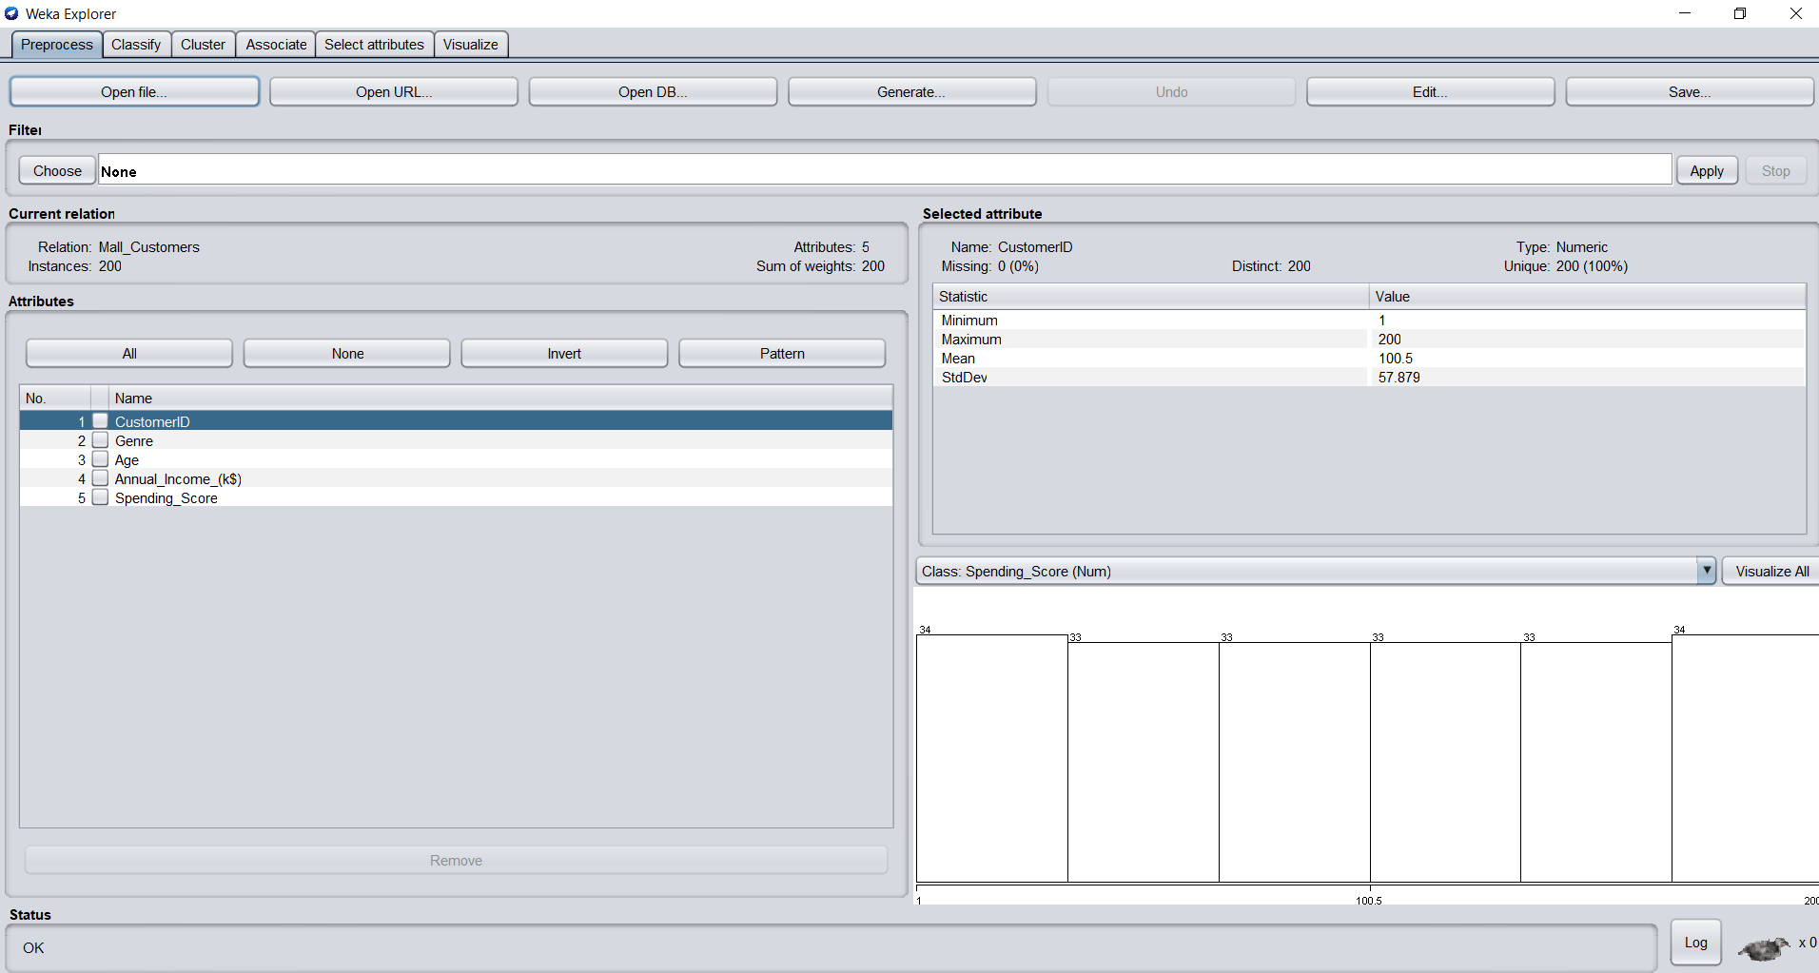

**Step 2-** In the Cluster section choose SimpleKMeans and click on start, we get output 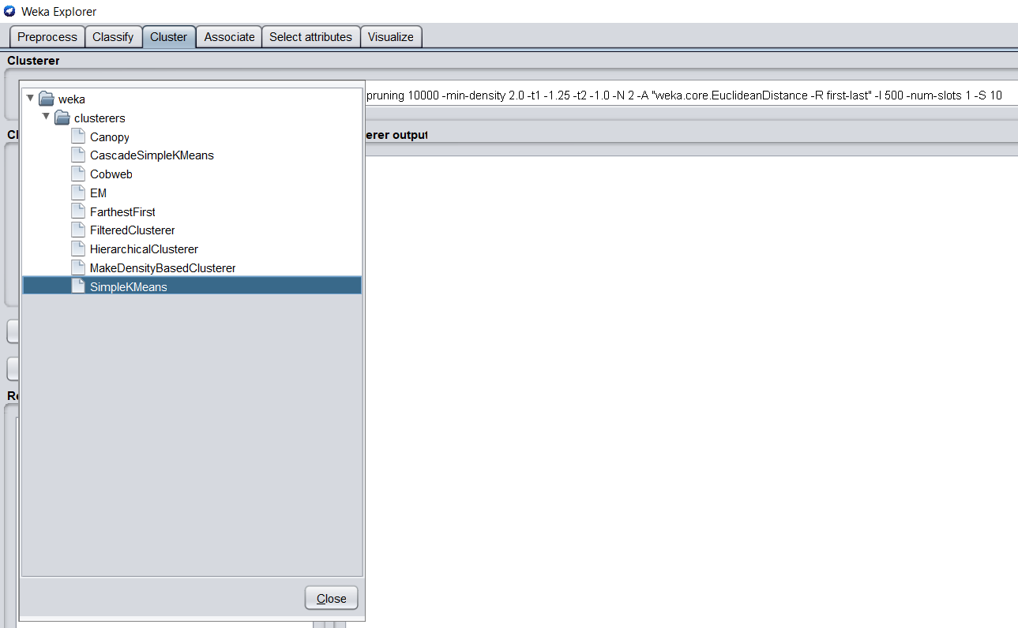

**Analyze the result-**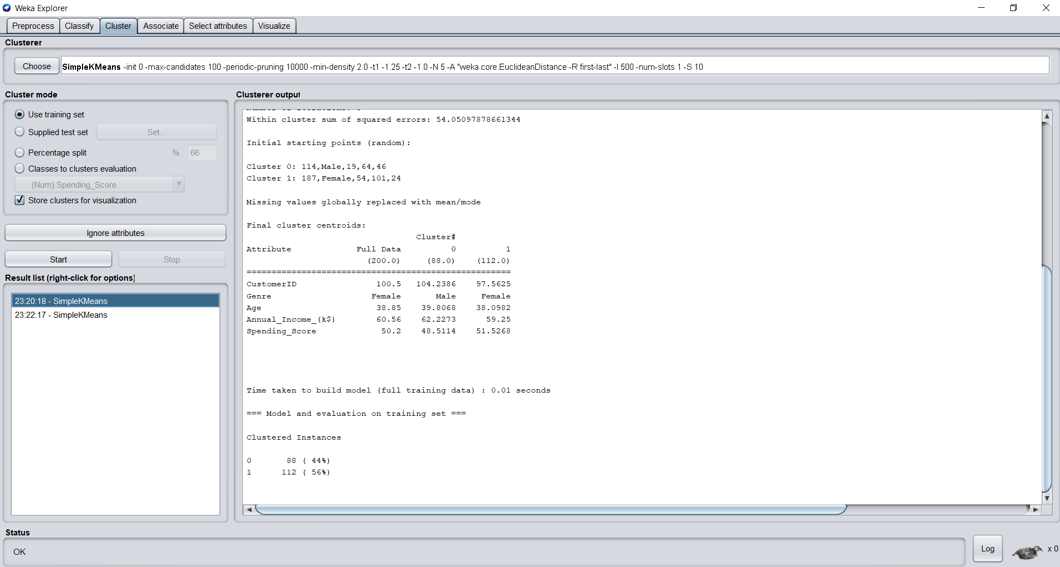

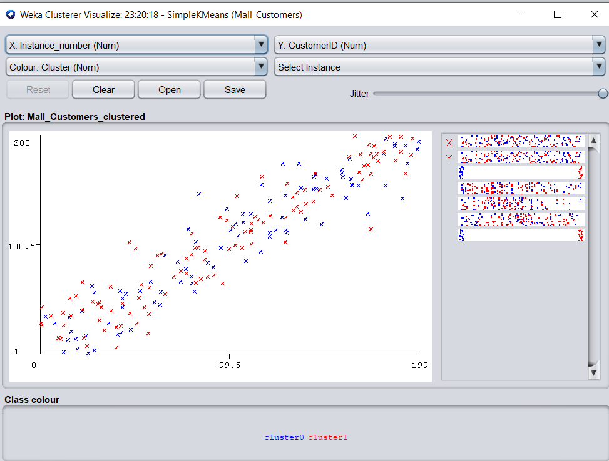

**For Cascade K means :**

**Step1:** Select CascadeSimpleKmeans from choose option.

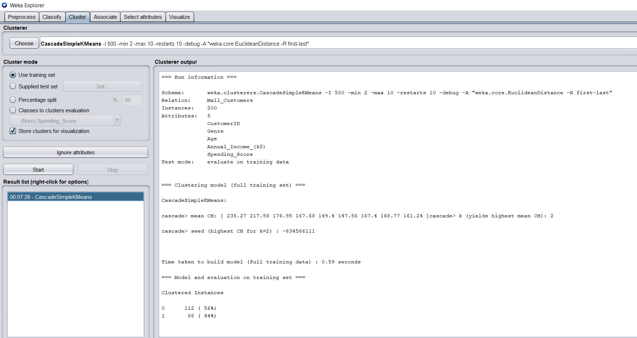

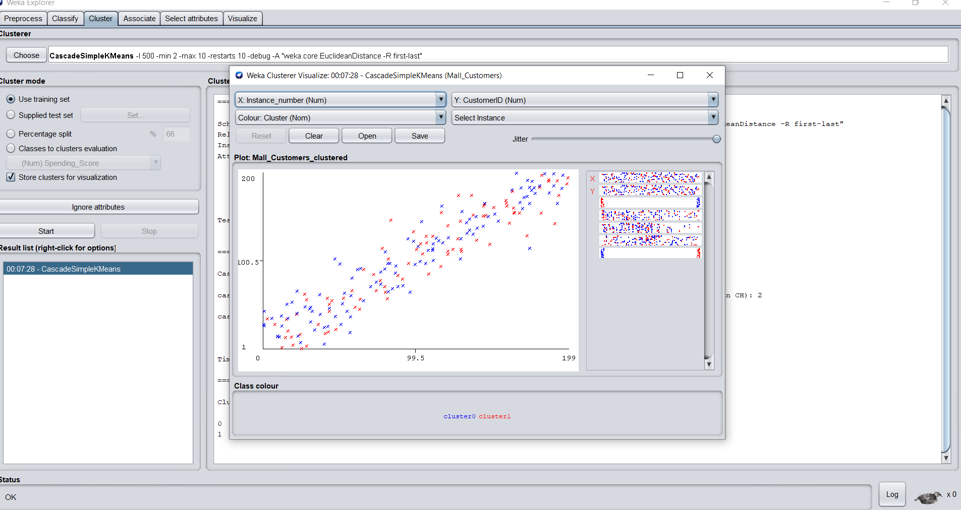

**Applying K-Means Algorithm for K = 5:**

Right-click on choosing after selecting the SimpleKMeans option we get the list shown in the picture, change the numClusters value to 5.

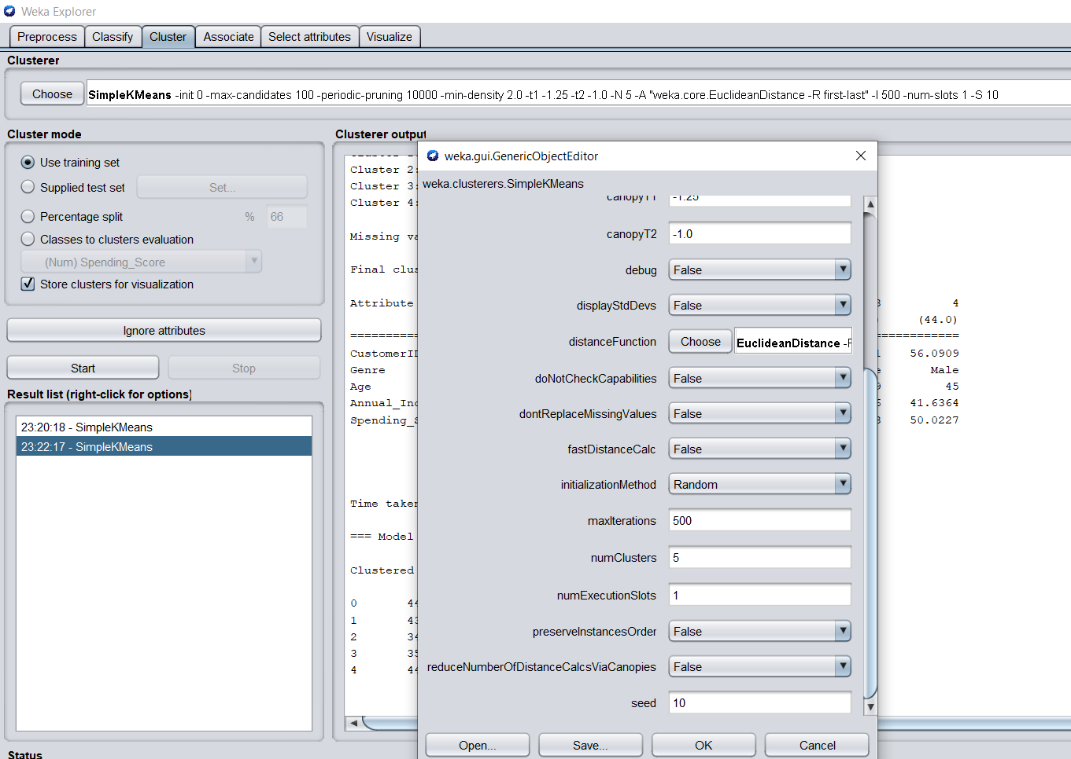

**Output-** After clicking on the Start button we get output

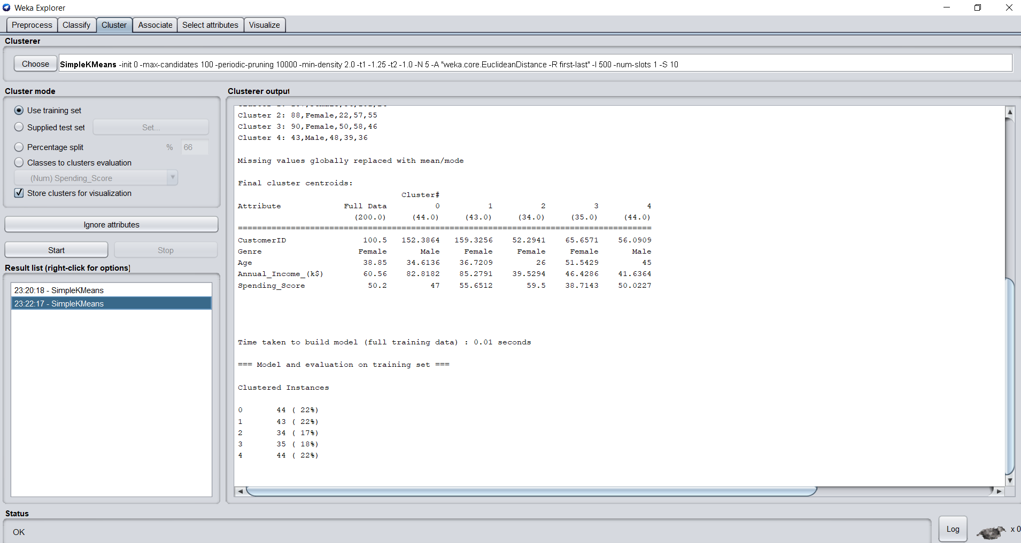

**Analyze the result:**

We get 5 different groups on visualization because we put numClusters as 5 before we get 2 different groups because by default the value of numClusters is 2. Within cluster sum of squared errors: 54.05(for numcluster = 2 ). Within cluster sum of squared errors: 30.35(for numCluster = 5)error is reduced significantly.

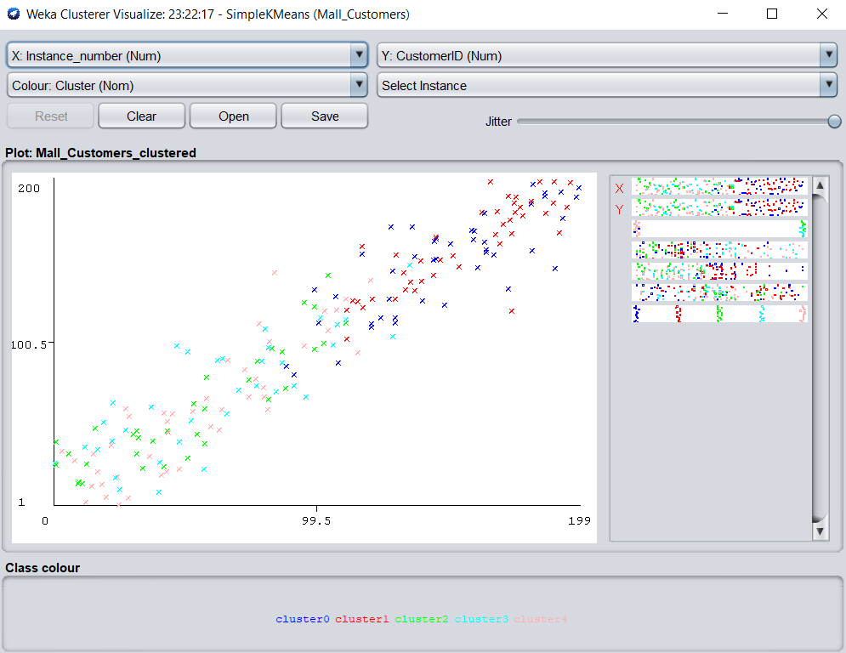

**EXPERIMENT 10**

**Identify a dataset for applying Component Analysis and understand the result. Do the proper analysis of the result with the help of Standard Deviation.**

**Theory:**

**Principal Component Analysis:**

Principal Component Analysis is an unsupervised learning algorithm that is used for dimensionality reduction in machine learning. It is a statistical process that converts the observations of correlated features into a set of linearly uncorrelated features with the help of orthogonal transformation. These new transformed features are called the Principal Components. It is one of the popular tools that is used for exploratory data analysis and predictive modeling. It is a technique to draw strong patterns from the given dataset by reducing the variances.

**What type of data should be used for PCA?**

PCA works best on **data set having 3 or higher dimensions**. Because, with higher dimensions, it becomes increasingly difficult to make interpretations from the resultant cloud of data. PCA is applied to a data set with numeric variables.

**Applying Principal Component in WEKA-**

**Step 1-** Choose cpu.arff dataset from data folder of Weka.

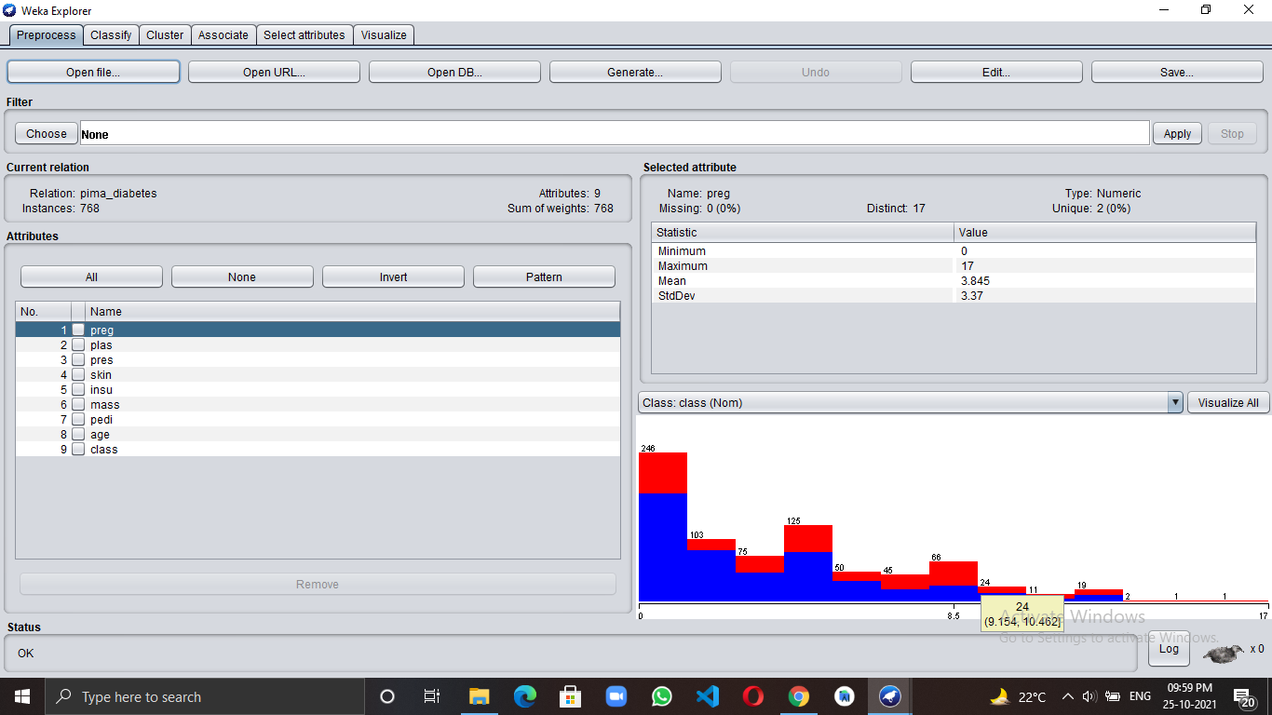

**Step 2-**

**Select weka>attributeSelection>principal Components.**

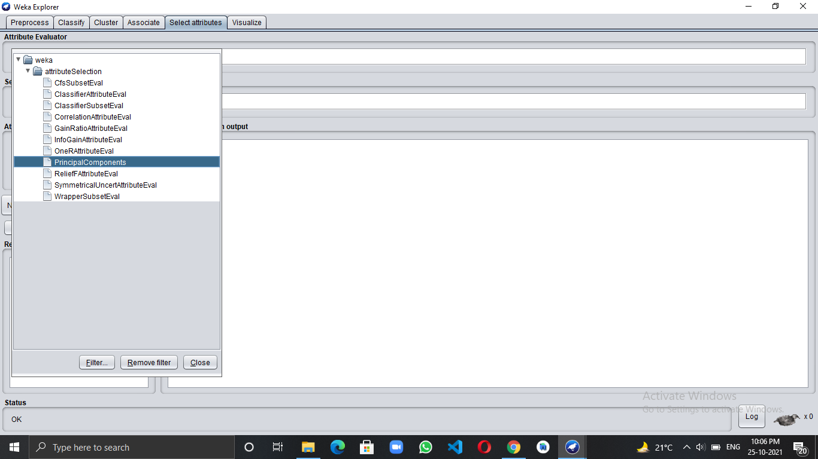

**Output -** After clicking on the Start button we get output

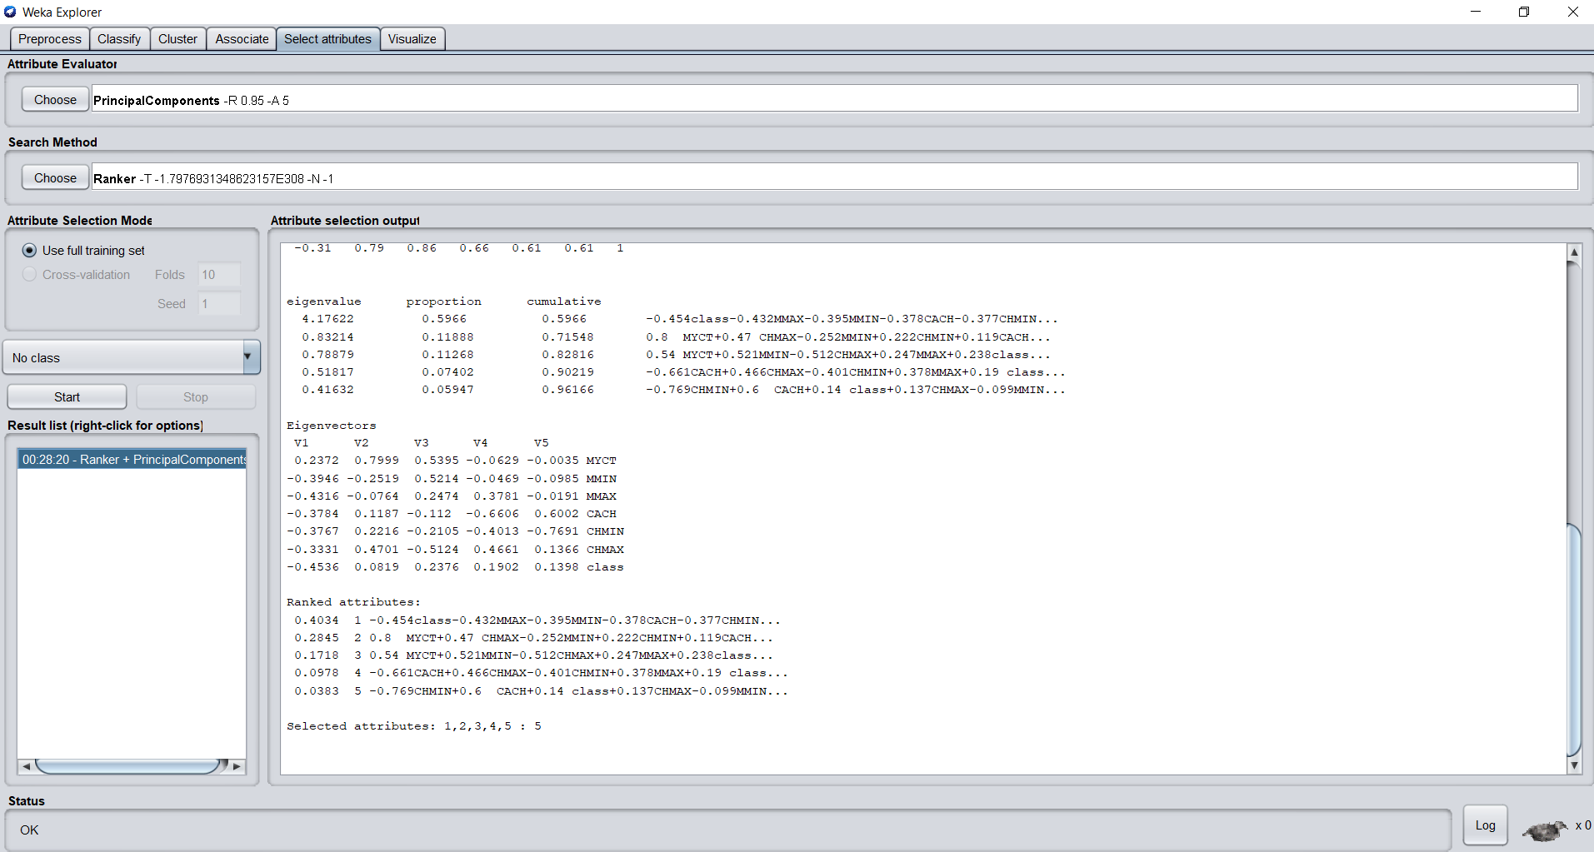

**Step 1:**

now in preprocess select filter>unsupervised>attribute>principalComponents.

**Step 2:**

Apply the filter

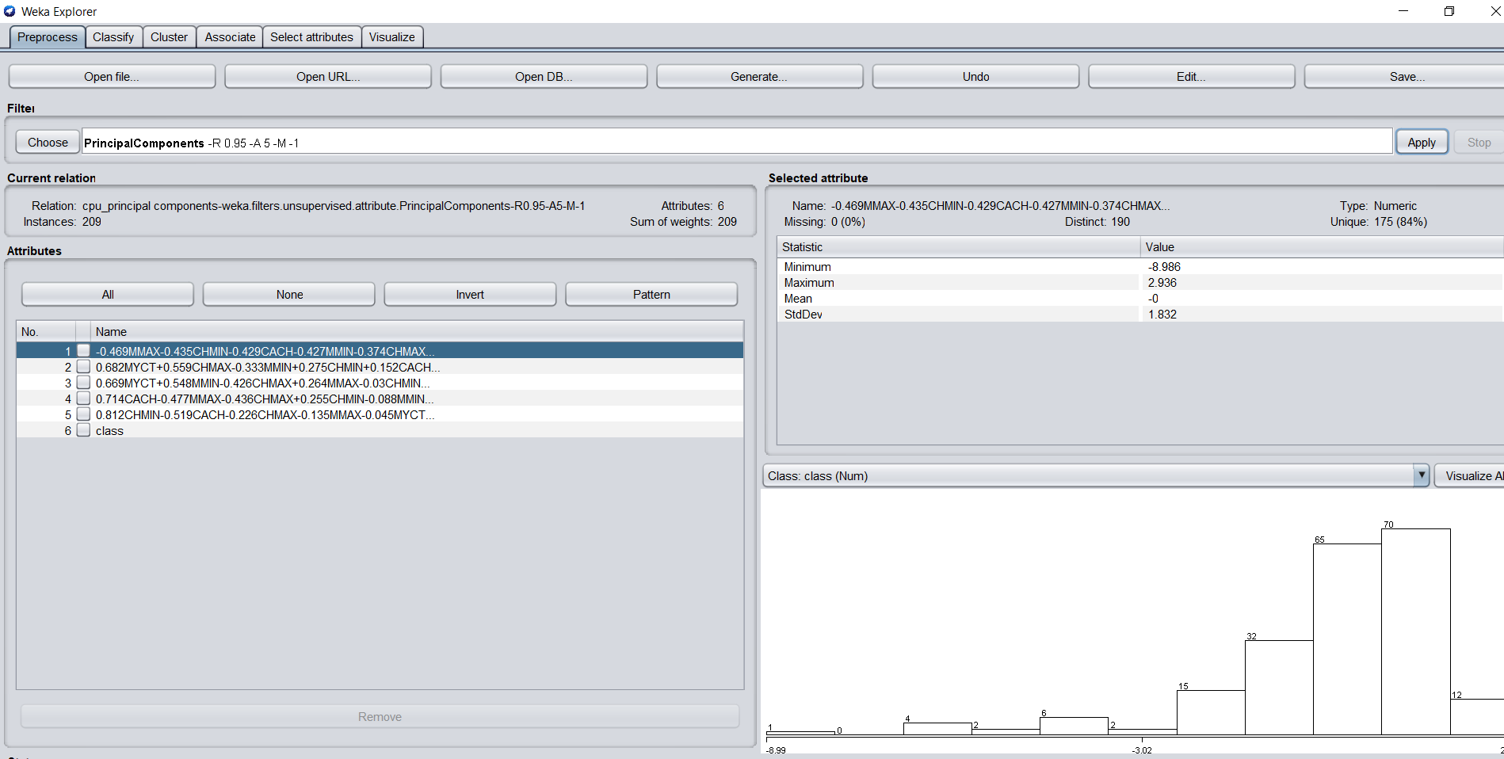

**Step 3:**remove the bottom attribute least signifact attributes don’t remove the class attribute.

**Step4:** select the filter logistic Regression from classify and press start.

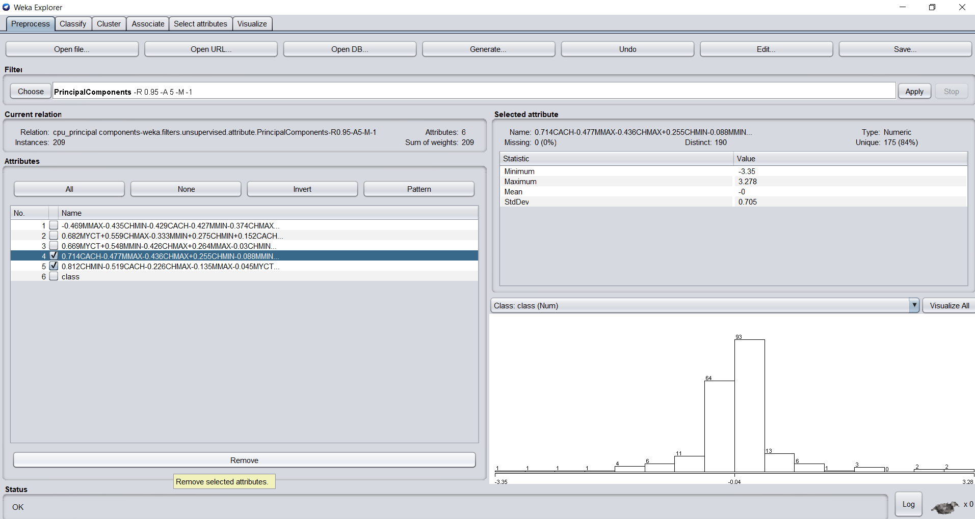

**result for logistic Regression.**

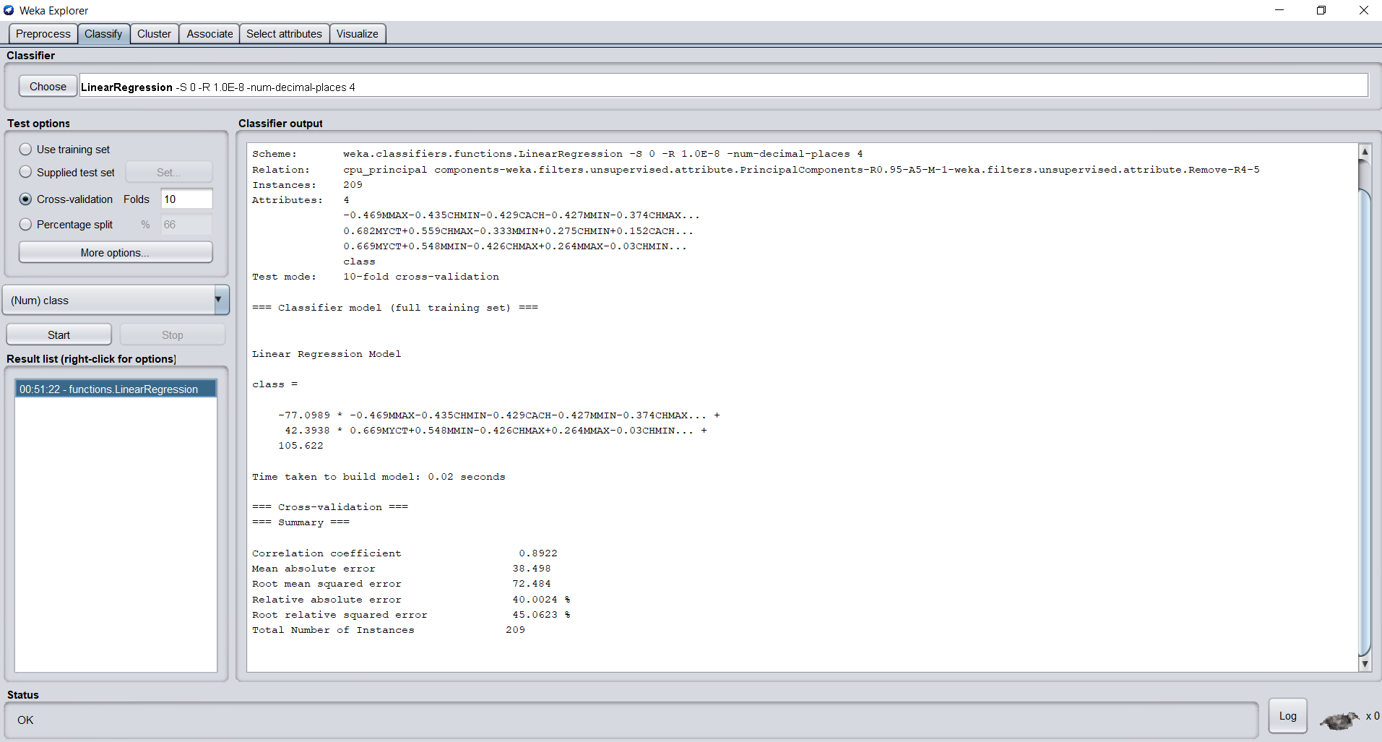

**Also applying Simple K-means Clustering**

Simple k means is applied after deleting least significant attribute.  
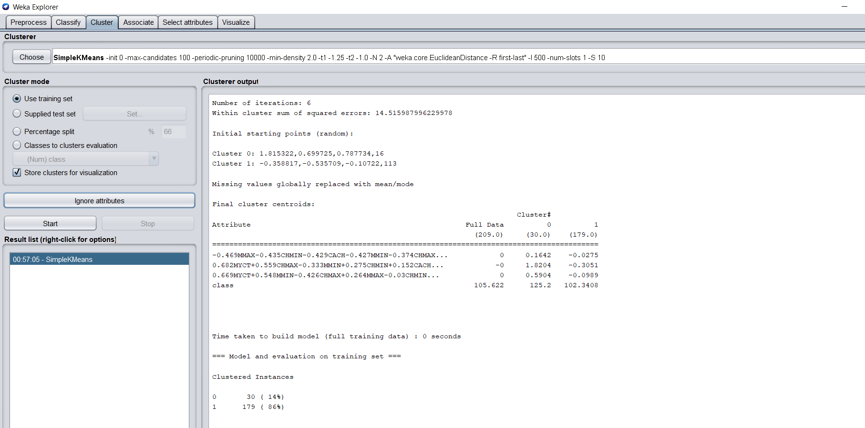

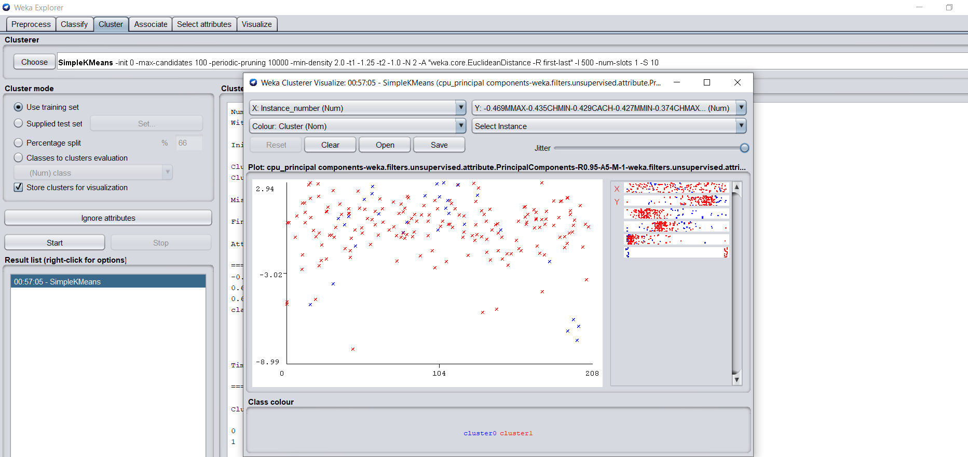

PCA is a unsupervised learning algorithm so K-means clustering reduced error significantly.